A

PROJECT REPORT

ON

**“E-FARMING: SHOPPING SYSTEM”**

Towards partial fulfilment of the requirement in

**5th Semester BCA (2022-23)**

**Submitted by:**

Shree Koshti (200510101061)

Jay Gandhi (200510101034)

Purvesh Bavashiya (200510101011)

**Submitted To:-**



**Parul Institute of Computer Application,**

Parul University

Under the guidance of

Assistant Professor, Manoj Kamber

**Acknowledgement**

*The success and final outcome of this project required a lot of guidance and assistance from many people and we are extremely privileged to have got this all along the completion of our project. All that we have done is only due to such supervision and assistance and we would not forget to thank them.*

*We respect and thank Dr Priya Swaminarayan, Dean, FITCS for providing us an opportunity to do the project work in BCA and giving us all support and guidance, which made us complete the project duly. We are extremely thankful to Mam for providing her support and guidance, although she had busy schedule managing the academic affairs.*

*We would not forget to remember Prof. Hina Chokshi, HOD, BCA department for her encouragement and more over for her timely support and guidance till the completion of our project work.*

*We owe our deep gratitude to our project guide Prof. Manoj Kamber, who took keen interest on our project work and guided us all along, till the completion of our project work by providing all the necessary information for developing a good system.*

*We are thankful to and fortunate enough to get constant encouragement, support and guidance from our Parents, all Teaching staffs of BCA Department which helped us in successfully completing our project work. Also, we would like to extend our sincere esteems to all staff in laboratory for their timely support.*

***[Shree Koshti] [200510101061]***

***[Jay Gandhi] [200510101034]***

***[Purvesh Bavashiya] [200510101011]***



PARUL INSTITUTE OF COMPUTER APPLICATION

**CERTIFICATE**

This is to certify that ***SHREE KOSHTI, JAY GANDHI, PURVESH BAVASHIYA*** the student(s) of Parul Institute of Computer Application, has/have satisfactorily completed the project entitled “***E-FARMING: SHOPPING SYSTEM****”* as a part of course curriculum in BCA / IMCA semester-V for the academic year 2022-2023 under guidance of ***Asst.*** ***Prof. MANOJ KAMBER.***

Enrollment Number: 200510101061

Enrollment Number: 200510101034

Enrollment Number: 200510101011

|  |  |  |
| --- | --- | --- |
| **Quality of work** | **Grade** | **Sign of Internal guide** |
| **Poor / Average / Good /**  **Excellent** | **B /B+ / A / A+** |  |

Date of submission:

HOD, Principal,

**Prof. Hina Chokshi** **Dr Priya Swaminarayan**

**INDEX**

1. Research 1

2. Feasibility Studies 2

3. System Requirement Specification 4

4. Technology Description 8

5. Data Flow Diagram 9

6. Use Case Diagram 17

7. Class Diagram 18

8. Activity Diagram 19

9. E-R Diagram 21

10. Data Dictionary 22

11. Form Design 34

12. What is testing? 46

13. Future Enhancement 48

14. References & Bibliography 49

**INDEX OF FIGURES**

Figure 1: Time Line Chart 7

Figure 2: Context Level DFD: 0 Level 9

Figure 3: User Level 1 10

Figure 4: Admin Level 1 11

Figure 5: User Level 2: All Products 12

Figure 6: Admin Level 2: Order List 12

Figure 7: Admin Level 2: Manage Payments 13

Figure 8: Admin Level 2: CMS Web Content 13

Figure 9: Admin Level 2: Manage User 14

Figure 10: User Level 2: Authentication 15

Figure 11: User Level 2: All Products 15

Figure 12: User Level 2: My Cart 16

Figure 13: User Level 2: Checkout 16

Figure 14: Use Case 17

Figure 15: Class Diagram 18

Figure 16: Activity Diagram: User 19

Figure 17: Activity Diagram: Admin 20

Figure 18: ER Diagram 21

Figure 19: Add to Cart Functionality 34

Figure 20: Product Page 34

Figure 21: Cart Page 35

Figure 22: Cart page Code 35

Figure 23 : Checkout Page 36

Figure 24 : Checkout Page Code 36

Figure 25 : Home Page - 1 37

Figure 26 : Home Page – 2 37

Figure 27 : Home Page Code 38

Figure 28 : My Account Design 38

Figure 29 : My Account Code 39

Figure 30 : Admin SideBar Design 40

Figure 31 : Admin Sidebar Code 40

Figure 32 : Products Page – Admin 41

Figure 33 : Product Page Code - Admin 41

Figure 34 : Paytm Payment Design 42

Figure 35 : Paytm Payment Code 42

Figure 36 : Order Confirm Email Template Design 43

Figure 37 : Order Confirm Email Template Code 43

Figure 38 : Change password Validations Page 44

Figure 39 : Edit Profile page Validations 44

Figure 40 : Login Page Validations 45

# Research

## What is research?

Research is defined as careful consideration of study regarding a particular concern or problem using scientific methods. It is a systematic inquiry to describe, explain, predict and control the observed phenomenon. It involves inductive and deductive methods.

## Types of Research Methodology

Research methods are broadly classified as Qualitative and Quantitative. Both methods have distinctive properties and data collection methods.

### Qualitative Methods

This is a type of research method in which we collect data using face-to-face conversation, usually with open-ended questions. Using this method, we came to know our lack of requirements in the eFarm: shopping system. These types methods include:

* One-to-one interview

At this stage, we collected information from selected candidates about our system UI and basic requirements.

* Focus Groups

At this stage, we took all the same selected candidates for group discussion. The primary focus of this discussion was gathering ideas from all of the candidates for our eFarm: shopping system.

* Ethnographic studies
* Text Analysis
* Case Study

### Quantitative Methods

This is a type of research method in which we take very basic data from a group of samples in numbers and measurable forms. It uses a systematic way of investigating events or data. It answers questions to justify relationships with measurable variables to either explain, predict or control a phenomenon. Types of quantitative methods include:

* Survey research

At this stage, we conducted a survey to know the basic requirements for our system; those requirements which are countable or non-additional (here we used MCQ questions for the survey).

* Descriptive research

At this stage, we took a random sample of the population and got feedback from them about our system. In addition, we asked them about their ideas for our system.

# Feasibility Studies

## What is Feasibility?

As the name implies, a feasibility analysis is used to determine the viability of an idea, such as ensuring a project is legally and technically feasible as well as economically justifiable. It tells us whether a project is worth the investment in some cases, a project may not be doable. There can be many reasons for this, including requiring too many resources, which not only prevents those resources from performing other tasks but also may cost more than an organization would earn back by taking on a project that isn’t profitable.

A well-designed study should offer a historical background of the business or project, such as a description of the product or service, accounting statements, details of operations and management, marketing research and policies, financial data, legal requirements, and tax obligations. Generally, such studies precede technical development and project implementation.

## Technical Feasibility

This assessment focuses on the technical resources available to the organization. It helps organizations determine whether the technical resources meet capacity and whether the technical team is capable of converting the ideas into working systems. Technical feasibility also involves the evaluation of the hardware, software, and other technical requirements of the proposed system. As an exaggerated example, an organization wouldn’t want to try to put Star Trek’s transporters in their building—currently, this project is not technically feasible.

## Economic Feasibility

This assessment typically involves a cost/ benefits analysis of the project, helping organizations determine the viability, cost, and benefits associated with a project before financial resources are allocated. It also serves as an independent project assessment and enhances project credibility—helping decision-makers determine the positive economic benefits to the organization that the proposed project will provide.

## Operational Feasibility

Determine the viability, cost, and benefits associated with a project before financial resources are allocated. It also serves as an independent project assessment and enhances project credibility—helping decision-makers determine the positive economic benefits to the organization that the proposed project will provide.

## Importance of Feasibility Studies

A feasibility study is conducted to determine the success and minimize the risks related to the project. It is not merely project research, but a framework or a plan on how to establish and run a business successfully in the long run. It contains five essential components, including market research, financial research, management research, schedule determination, and technical research.

## Feasibility Study of our Proposed System



## Technical Feasibility:

* In this proposed system, technical feasibility depends on open-source tools and technologies.
* In this system technologies like HTML, CSS, JavaScript, Python (Django Framework), Postgres, Bootstrap used.

### Economical Feasibility:

* Development Costs:

The system is economically feasible as its costs nothing because all depend on open source.

* Production Costs**:**

Hosting cost, operation, and maintenance cost including software and hardware upgrading.

### Operational Feasibility:

* The main purpose of the proposed system is that it will solve the task of farmers by finding their framing products.
* Farmers will be able to find the needed product easily with our user-friendly UI.
* This system manages all the users and their orders.

# System Requirement Specification

## Introduction To SRS

## What is SRS?

A software requirements specification (SRS) is a description of a software system to be developed. It lays out functional and non-functional requirements and may include a set of use cases that describe user interactions that the software must provide.

### Need of SRS

To fully understand one’s project, they must come up with an SRS listing out their requirements, how are they going to meet it and how will they complete the project. It helps the team to save upon their save upon their time as they are able to comprehend how are going to go about the project. Doing this also enables the team to find out about the limitations and risks early on.

## 3.2. Abstract

Our group has made a project on E-FARMING: SHOPPING SYSTEM. We have developed it by using python Django framework. The system is implemented to reduce the manual work and enhances the accuracy of work in a farming. This system manages and maintains the record of customers and their order online. This project has been made in a user-friendly interface. So that Customer can add and delete the products easily. Through the place ordering products, the customer can simply click and order the products. This system entirely reduces the unnecessary time of farmer.

Looking towards the problems faced by farmers, i.e., unavailability of good quality seeds, lack of modern equipment and machinery, poor irrigation facilities, and so on, our website will make them available with all of the products, which results in fewer conflicts

A farmer can purchase seeds, tools, fertilizer etc., so this can help the farmers by reducing their time of going out for getting products.

## System Users

### Admin

An admin or manager is the person who will manage the entire web site. He can manipulate web content, being able to see the number of users as well as payments made by any particular user. He can edit the product information, such as its price, items available, etc.

### User

Users will be able to buy products, apply coupons, make payments, and view their profile.

## Modules

* Authentication Module
* User Account Module
* Products Module
* Add to Cart Module
* Order Module
* Payment Module

## Modules Description

### Authentication Module

It is a vital feature of our site. Because without a login, placing an order and making a payment is not possible. And the other reason for logging in is to avoid (to some extent) placing the fake payments.

### User Account Module

A user's user profile is also known as their mini-profile page. This will show all the details, like their ordered item list.

### Products Module

This module will take care of all product details.

### Add to cart Module

This module will take care of the user's selected products and show them the total cart price.

### Order Module

The Order module is useful for the admin to maintain all the orders of the user.

### Payment Module

For the payment, we are going to use the Paytm API. This will be managed under the payment module.

## Hardware Requirements (Developer)

|  |  |
| --- | --- |
| **Name of Components** | **Specification** |
| Processor | Intel Core i3/i5 |
| RAM | 8GB/12GB |
| Hard Disk | 512GB/1TB |

Table 1: Developer: Hardware Requirements

## Software Requirements (Developer)

|  |  |
| --- | --- |
| **Name of Components** | **Specification** |
| Operating System | Windows 8,9,10 |
| Software development Kit | Python |
| Tools & languages | Python (Django Framework), HTML, CSS, JavaScript, Bootstrap, Postgres |

Table 2: Developer: Software Requirements

## Hardware Requirements (User)

|  |  |
| --- | --- |
| **Name of Components** | **Specification** |
| Processor | Intel Core i3/i5, A15 Bionic Apple, Snapdragon 7 |
| RAM | 4GB |
| Hard Disk | 1 GB |

Table 3: User: Hardware Requirements

## Software Requirements (User)

|  |  |
| --- | --- |
| **Name of Components** | **Specification** |
| Operating System | Windows 8,9,10, Android, IOS, MAC |
| Basic Need/ Requirements | Internet Access |
| Tools | Chrome, MS Edge, Safari Etc. |

Table 4: User: Software Requirements

## Time Line Chart

|  |  |  |  |  |  |  |  |
| --- | --- | --- | --- | --- | --- | --- | --- |
| **Development phase** | ***75 Days*** | | | | | | **Duration**  **N**  **(days)** |
| 0to10 days | 11to20  days | 21to30 days | 31to40 days | 41to50 days | 51to75  days |
| **Requirement**  **Gathering** |  |  |  |  |  |  | 07 |
| **Analysis** |  |  |  |  |  |  | 09 |
| **Design** |  |  |  |  |  |  | 10 |
| **Development Phase 1** |  |  |  |  |  |  | 13 |
| **Development Phase 2** |  |  |  |  |  |  | 13 |
| **Development Phase 3** |  |  |  |  |  |  | 13 |
| **Documentation** |  |  |  |  |  |  | 10 |
| **Total time**  **(Days)** |  | | | | | | **75** |

Figure 1: Time Line Chart

# Technology Description

In the development of this proposed system Python (Django) is used. Python (Django) is a server scripting language, and a powerful tool for making dynamic and interactive Web pages. Python (Django) is a widely-used, free, and efficient alternative to competitors such as Flask. And other technology used are Python (Django framework), HTML, CSS, JavaScript and Postgres.



|  |  |
| --- | --- |
| **Existing System** | **New System** |
| Lack of payment options | New payment options added like UPI |
| Lack of login Options | New login options added like Google. |
| Admin page is not flexible | Admin page is flexible |
| User/User mail verification feature is not available. | User/User mail verification feature is available at the time of registration. |

## Features and Limitations of New System

Table 5 : Comparison Between Existing System and New System

# Data Flow Diagram

* 1. **Context Level DFD’s**

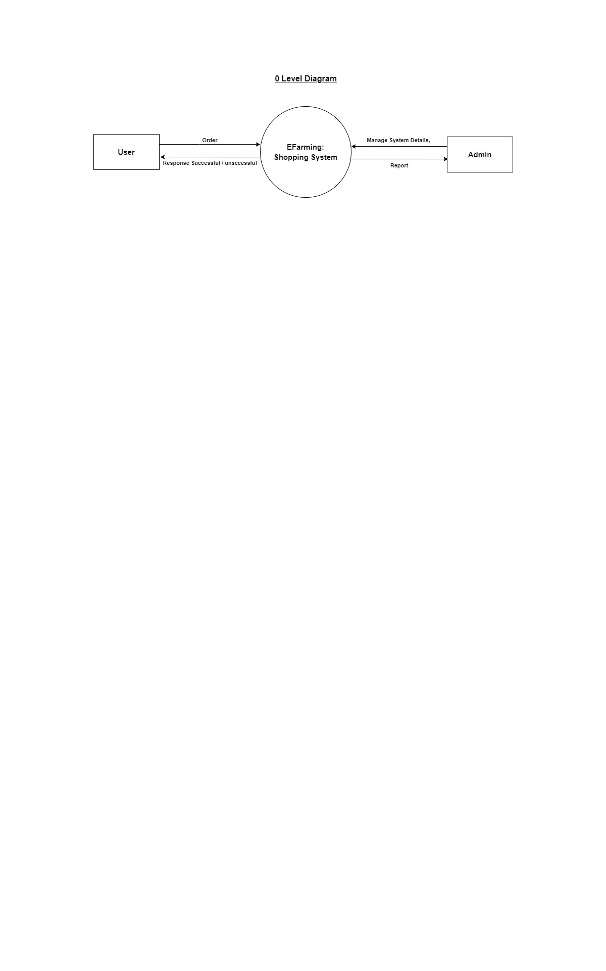

Figure 2: Context Level DFD: 0 Level

**Description:** DFD 0: this above diagram describe our system main activity or process.

* 1. **Level 1 DFD’s:**
* **User**

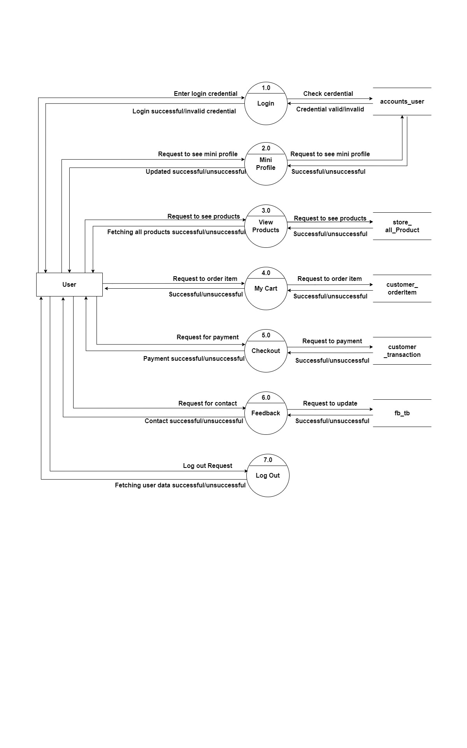

Figure 3: User Level 1

**Description:** DFD 1: this above diagram describes all the process that user can do.

* **Admin :**

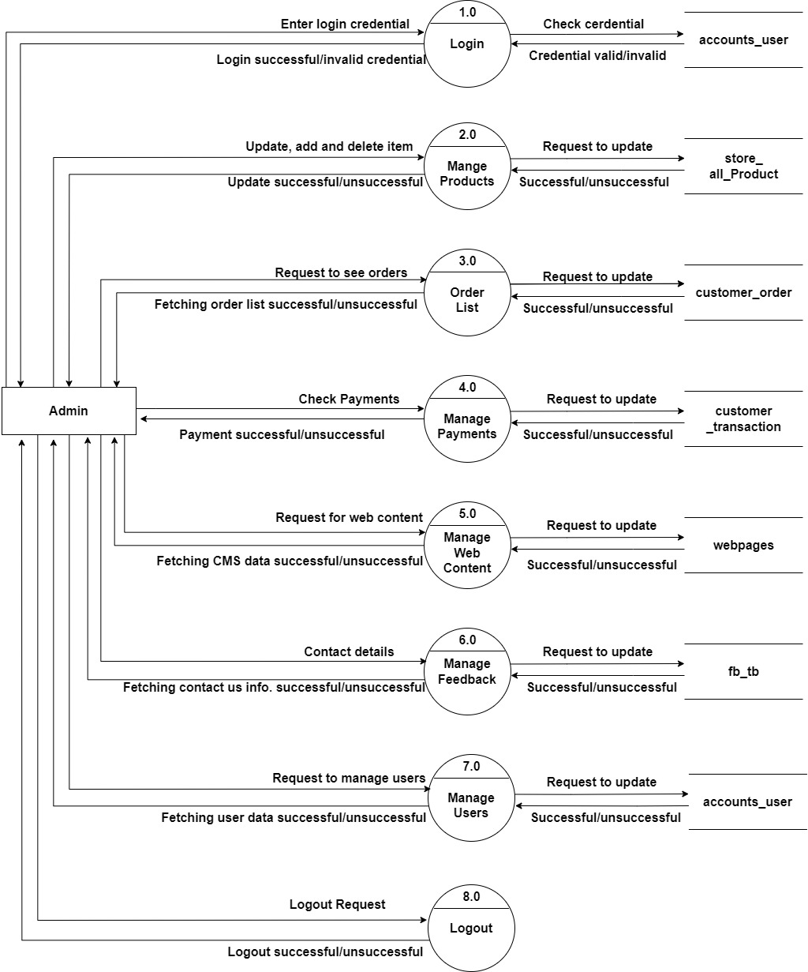

Figure 4: Admin Level 1

**Description:** DFD 1: this above diagram describes all the process that admin can do.

* 1. **Level 2 DFD’s**
* **Admin**

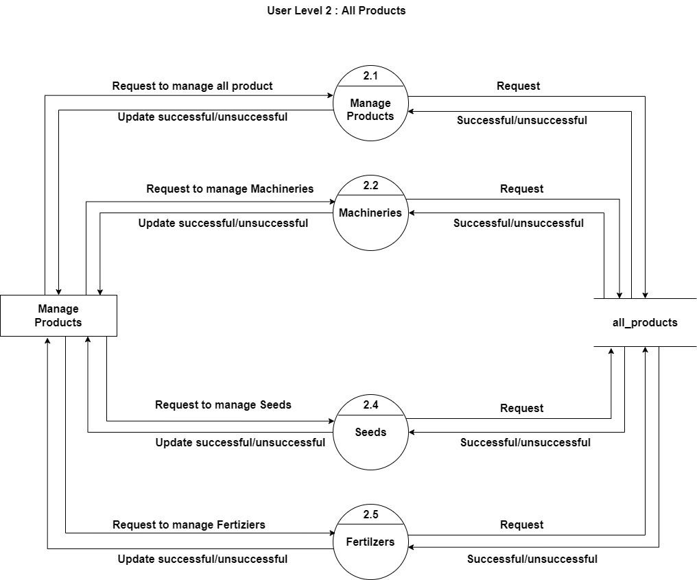

Figure 5: User Level 2: All Products

**Description:** DFD 2: this above diagram describes more in All products, shows us the subprocesses

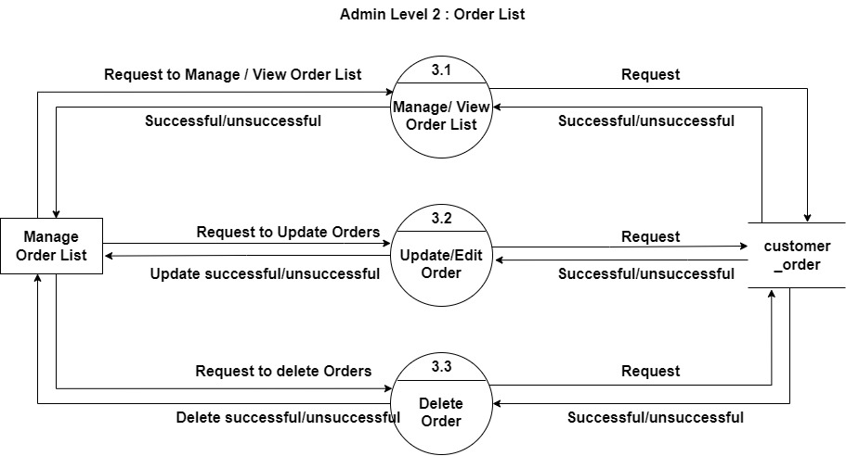

Figure 6: Admin Level 2: Order List

**Description:** DFD 2: this above diagram describes more in order list, shows us the subprocesses.

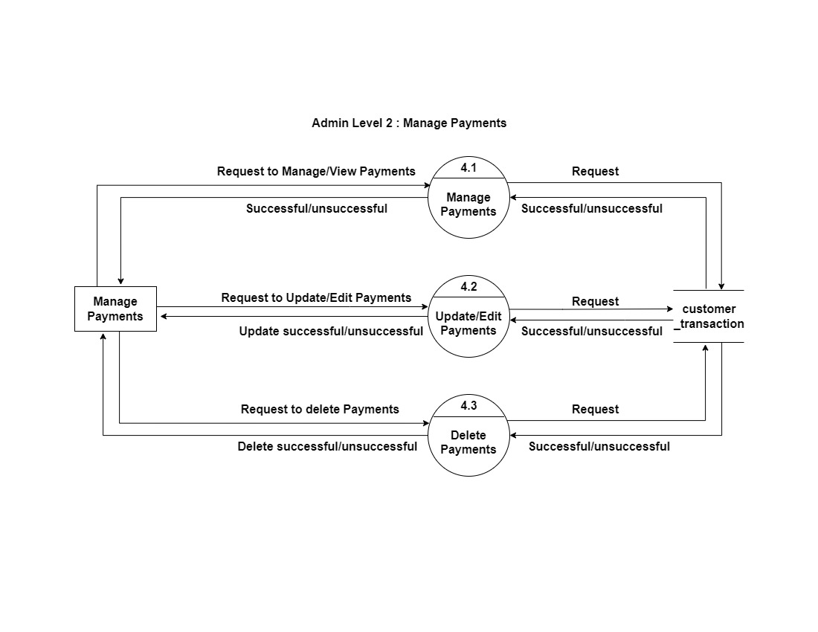

Figure 7: Admin Level 2: Manage Payments

**Description:** DFD 2: this above diagram describes more in manage payment, shows us the subprocesses.

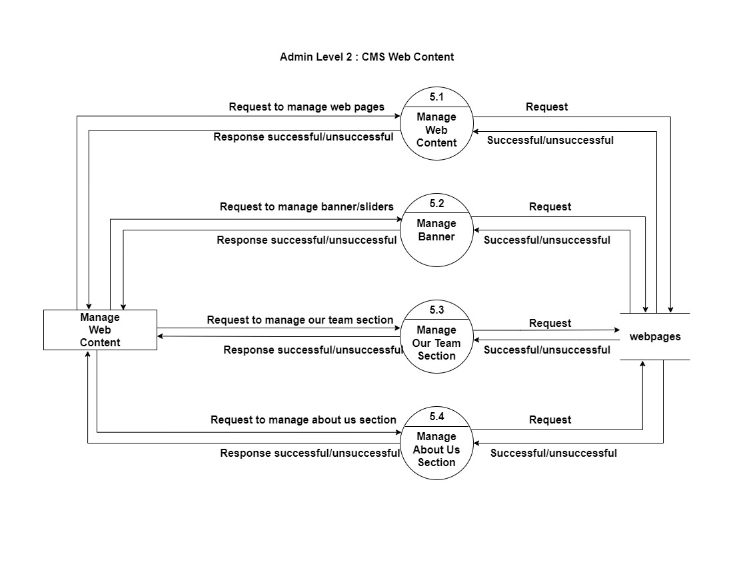

Figure 8: Admin Level 2: CMS Web Content

**Description:** DFD 2: this above diagram describes more in CMS Web Content, shows us the subprocesses

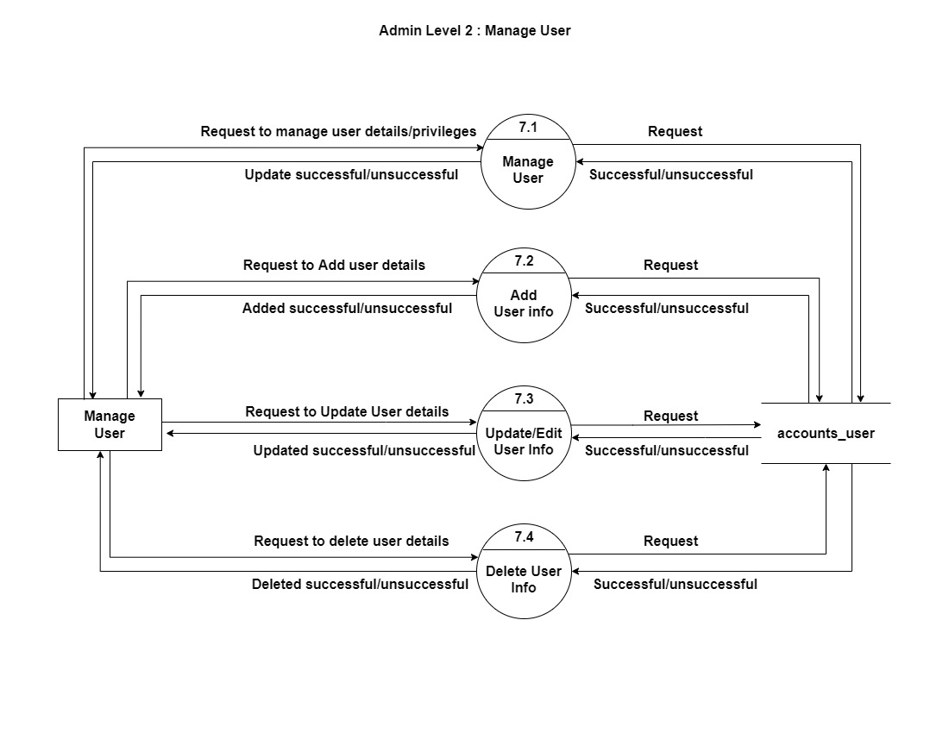

Figure 9: Admin Level 2: Manage User

**Description:** DFD 2: this above diagram describes more in Manage user, shows us the subprocesses.

* **User**

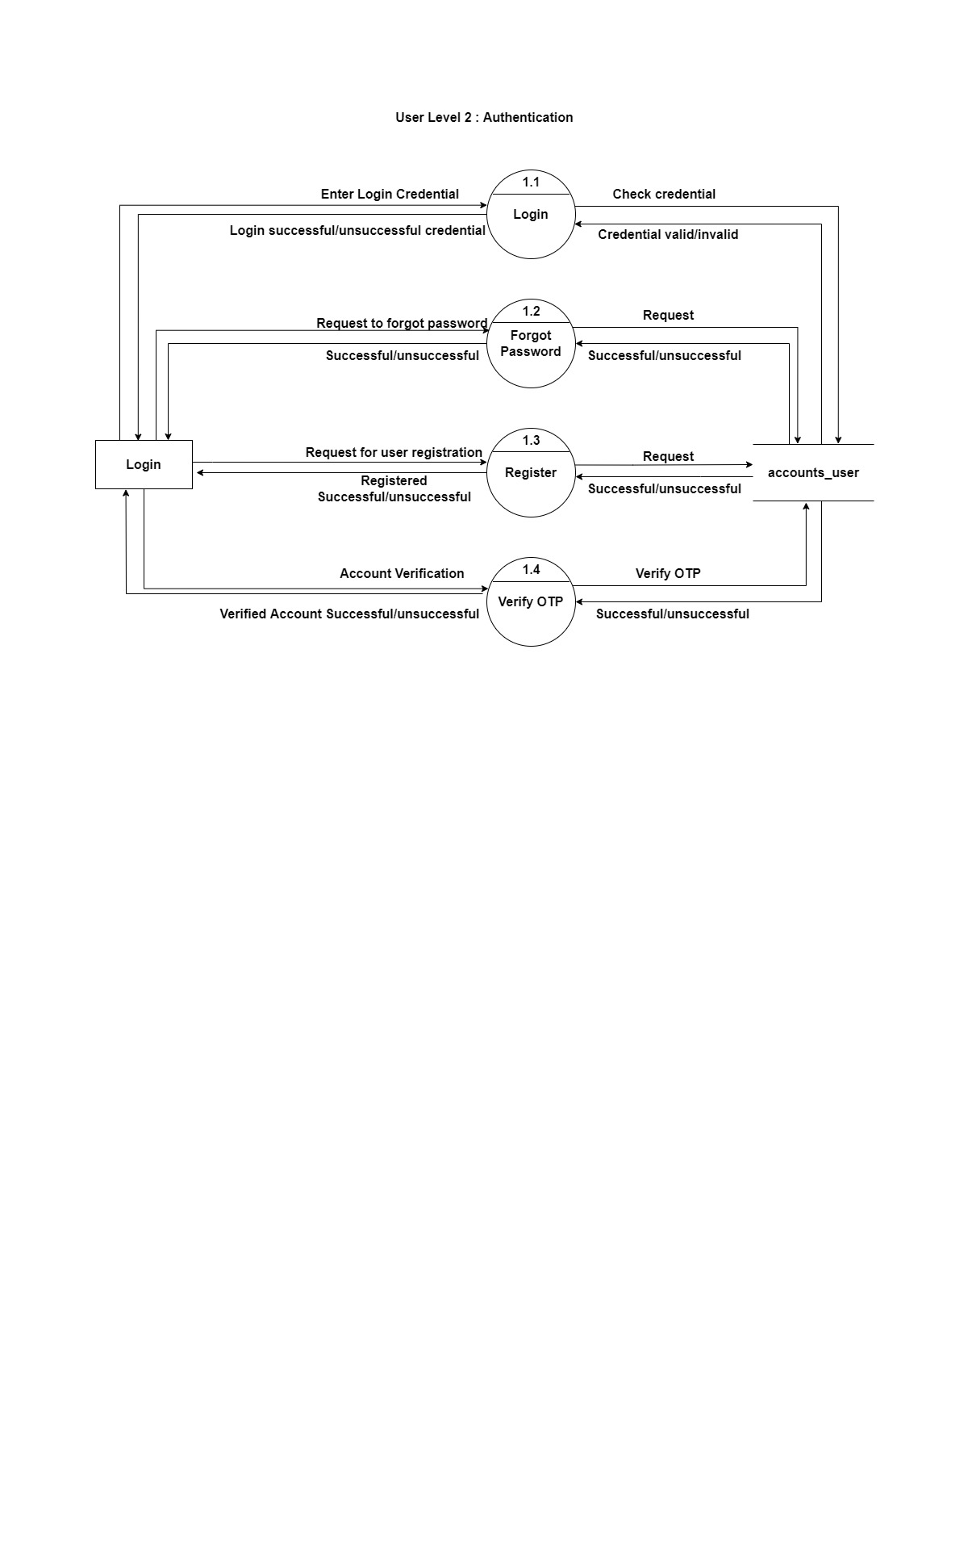

Figure 10: User Level 2: Authentication

**Description:** DFD 2: this above diagram describes more in Authentication, shows us the subprocesses.

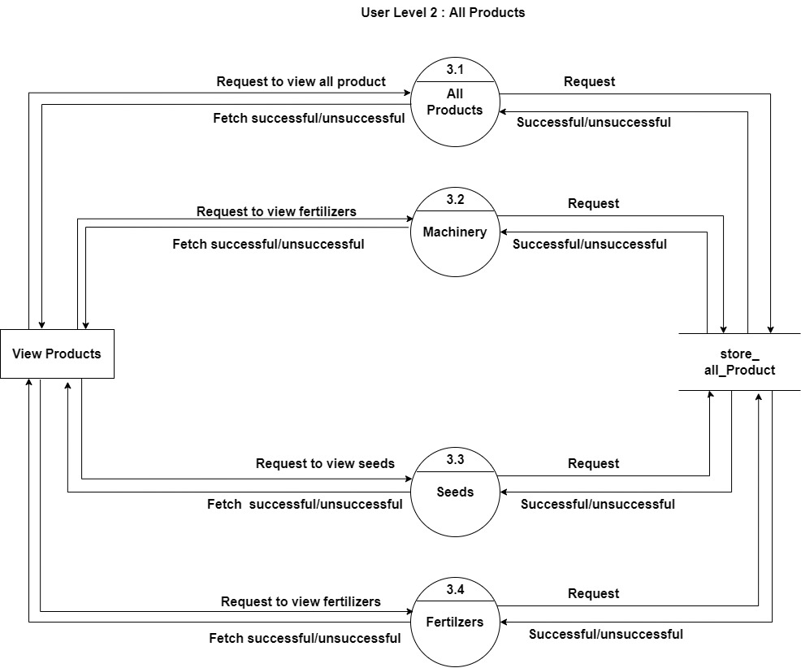

Figure 11: User Level 2: All Products

**Description:** DFD 2: this above diagram describes more in All products, shows us the subprocesses

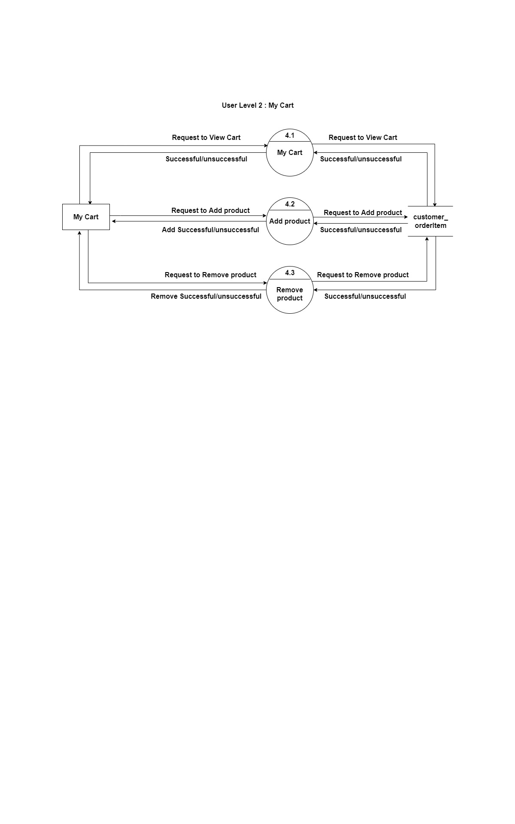

Figure 12: User Level 2: My Cart

**Description:** DFD 2: this above diagram describes more in My cart, shows us the subprocesses.

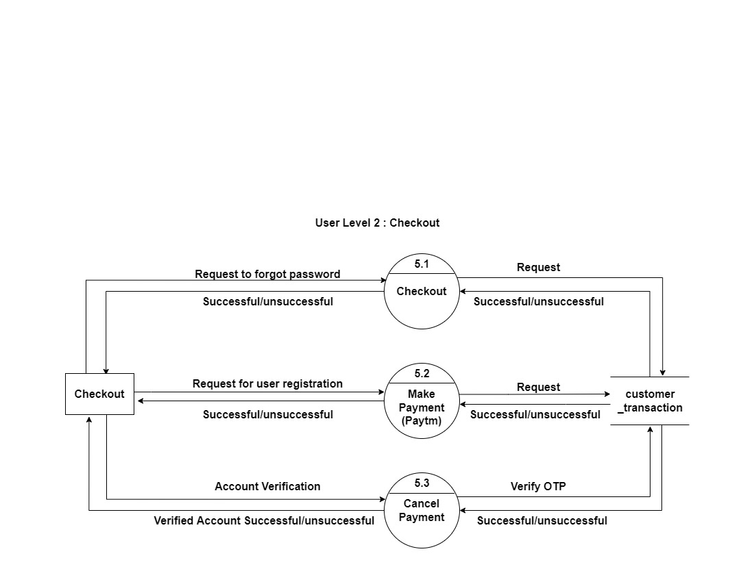

Figure 13: User Level 2: Checkout

**Description:** DFD 2: this above diagram describes more in Checkout, shows us the subprocesses.

# Use Case Diagram

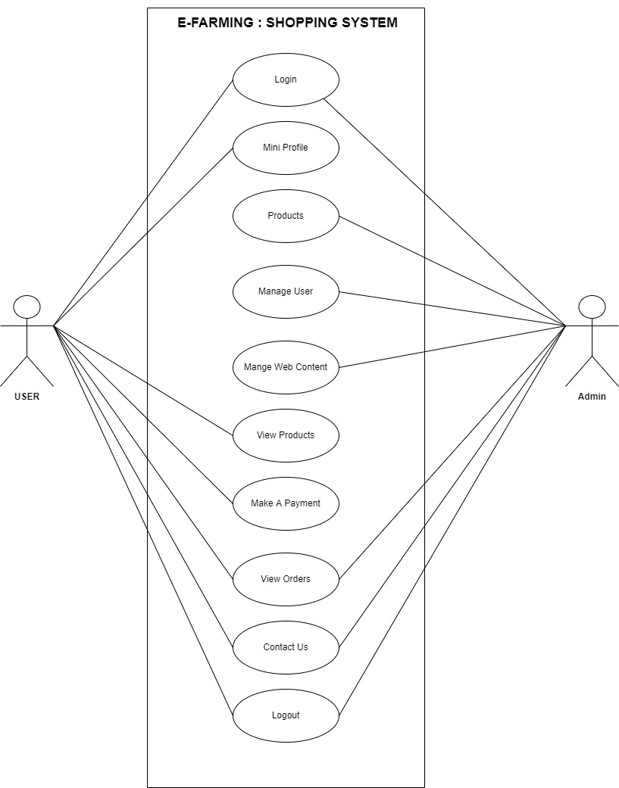

Figure 14: Use Case

**Description:** This is Use Case Diagram for E-farm: Shopping System, which shows the relationship between each actor and what functions they do.

# Class Diagram

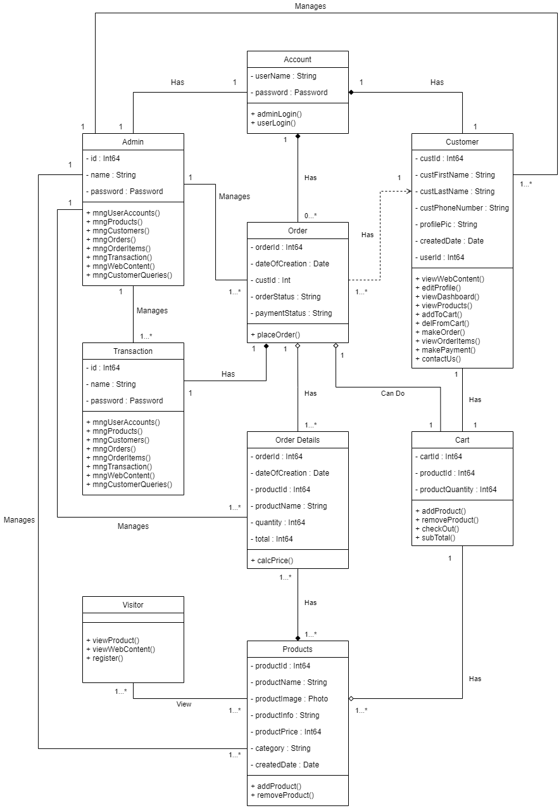

Figure 15: Class Diagram

**Description:** This is Class Diagram for E-farm: Shopping System, which shows the relationship between each entity and what functions they do.

# Activity Diagram

* **User**

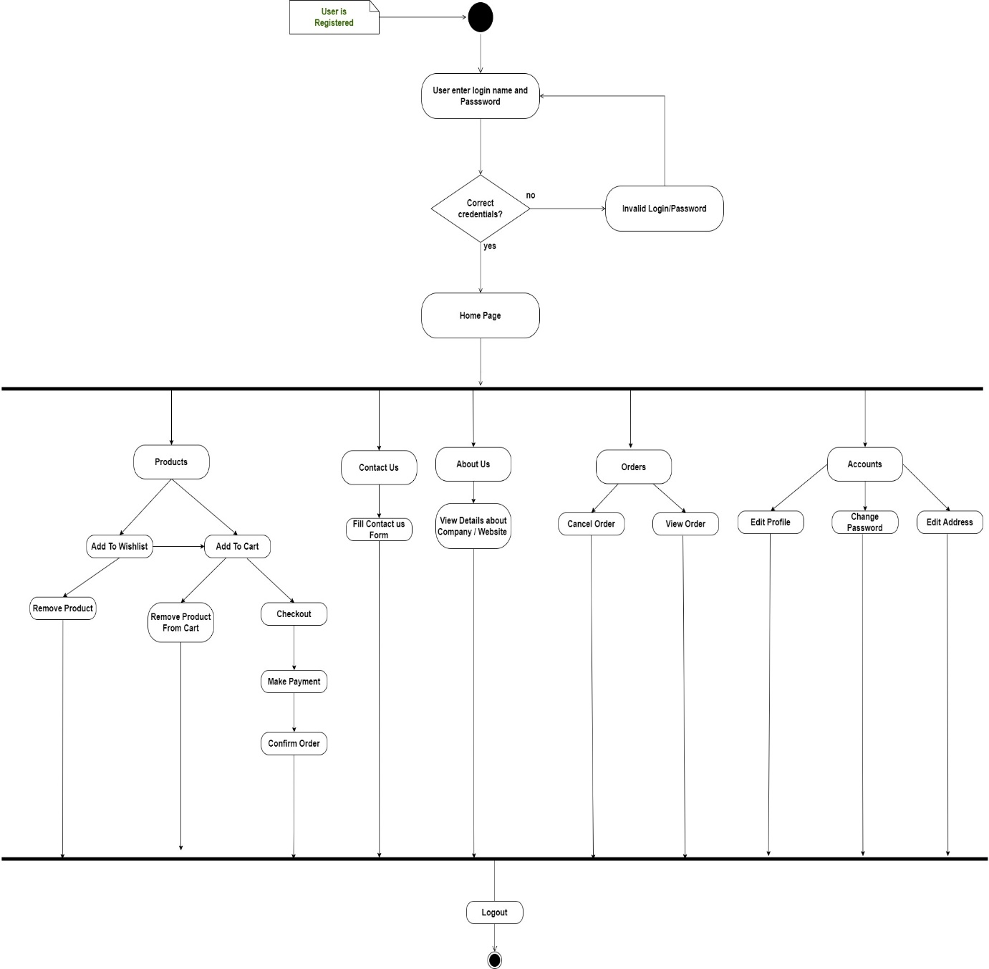

Figure 16: Activity Diagram: User

**Description:** This is an activity diagram of user for E-farm: Shopping System, which shows a series of action or flow of control in our system.

* **Admin**

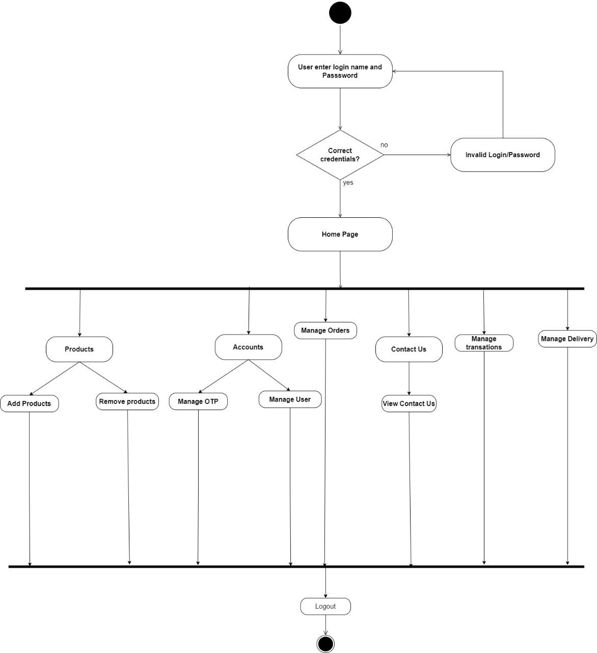

Figure 17: Activity Diagram: Admin

**Description:** This is an activity diagram of admin for E-farm: Shopping System which shows a series of action or flow of control in our system.

# E-R Diagram

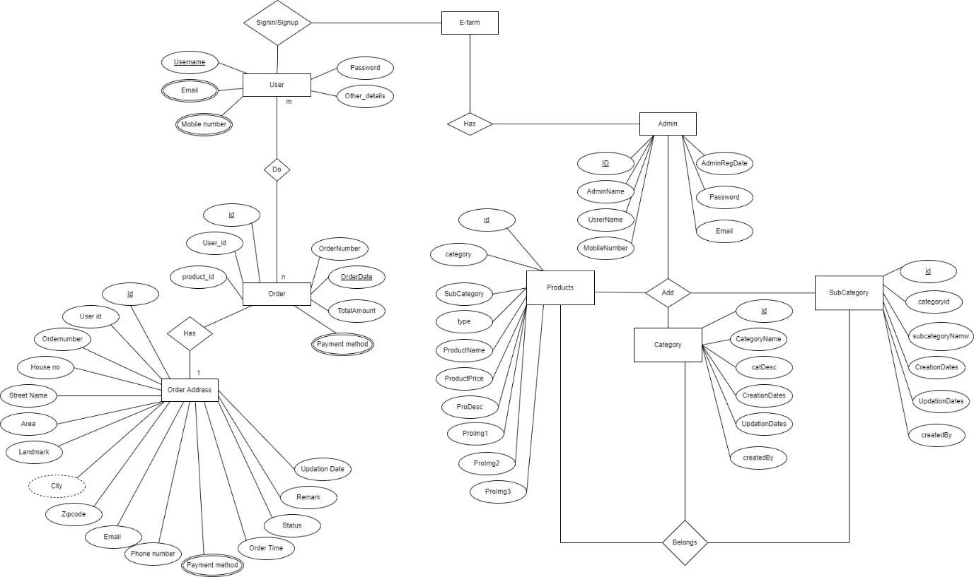

Figure 18: ER Diagram

**Description:** This is an ER Diagram for E-farm: Shopping System, which shows the graphical representation that depicts relationships among people, objects and events.

# Data Dictionary

1. **Table Name: accounts_customuser**

|  |  |  |  |  |  |  |
| --- | --- | --- | --- | --- | --- | --- |
| **Sr. No** | **Field Name** | **Datatype** | **Size** | **Description** | **Constraint** | **Example** |
| 1 | last_login | timestamp | - | Primary Key, AI | Unique id | 4 |
| 2 | is_superuser | boolean | - | Not Null | Is user user is admin or not | True / False |
| 3 | username | Varchar | 10 | Not Null | user unique name | Virat67 |
| 4 | first_name | varchar | 15 | Not Null | First Name of User | Virat |
| 5 | last_name | varchar | 15 | Not Null | Last Name Of user | Kohli |
| 6 | email | varchar | 25 | Not Null | User Email Id | abc@gmail.com |
| 7 | is_staff | boolean | - | Not Null | Is user is staff | True / False |
| 8 | is_active | boolean | - | Not Null | Is user Is active or not | True / False |
| 9 | date_joined | timestemp | - | Not Null | Date time of user | 2022-09-10 |
| 10 | phone | varchar | 10 | Null | User phone number | 7423658910 |
| 11 | is_verified | boolean | - | Not Null | Is user is verified or not | True / False |
| 12 | Password | Varchar | 128 | Not Null | Password of the account | ********* |

Table 6 : Table of Account_customer

**Table Description:** This table stores the information about registered user.

1. **Table Name: accounts_otpcode**

|  |  |  |  |  |  |  |
| --- | --- | --- | --- | --- | --- | --- |
| **Sr. No** | **Field Name** | **Datatype** | **Size** | **Description** | **Constraint** | **Example** |
| 1 | id | bigint | - | Primary Key, AI | Unique id | 4 |
| 2 | number | varchar | 5 | Not Null | Otp Number of user | 14569 |
| 3 | User_id | bigint | - | Foreign Key | Foreign Key from coustomer table | 9 |

Table 7 : Table of Accounts_otpcode

**Table Description:** This table store all otp codes of user.

1. **Table Name: customer_customer**

|  |  |  |  |  |  |  |
| --- | --- | --- | --- | --- | --- | --- |
| **Sr. No** | **Field Name** | **Datatype** | **Size** | **Constraint** | **Description** | **Example** |
| 1 | Id | Bigint | - | Primary Key, AI | Unique id of this table | 2 |
| 2 | First_name | Varchar | 255 | NOT NULL | First name of Customer | Virat |
| 3 | Last_name | Varchar | 255 | NOT NULL | Last name of Customer | Kohli2 |
| 4 | Phone_no | Bigint | - | NOT NULL | Phone number of the User | 9875524456 |
| 5 | User_id | Int | - | Foreign Key | (Foreign Key = id {From User Login Table (OneToOne Relationship)}) | 7 |
| 6 | Email | Varchar | 255 | NOT NULL | User Email Id | luk@123@gmail.com |
| 7 | Shipping_address | bigint | - | Foreign Key | Foreign Key from Shpping_Sddress table | 2 |

Table 6: Table of customer_customer

**Table Description:** This table shows information about customers.

1. **Table Name: Store_all_product**

|  |  |  |  |  |  |  |
| --- | --- | --- | --- | --- | --- | --- |
| **Sr. No** | **Field Name** | **Datatype** | **Size** | **Constraint** | **Description** | **Example** |
| 1 | Id | Bigint | - | Primary Key, AI | Unique id | 4 |
| 2 | Photo | Varchar | 100 | NOT NULL | Photo of the item | store/product/2022/item1.jpg |
| 3 | Product name | Varchar | 255 | NOT NULL | Name of the item | Multi Harvester |
| 4 | Description | Varchar | 255 | NOT NULL | Product Info | Item Description |
| 5 | Original_Price | int | - | NOT NULL | Product Price | 1000 |
| 6 | Created date | Timestamp with time zone | - | NOT NULL | Date of updating that Product | 2022-02-07  16:15:35.346967+05:30 |
| 7 | Category | Varchar | 255 | NOT NULL | Machinery, Crops,  Fertilizers, Seeds | Machinery |
| 8 | On_sale | boolen | - | Null | Product on sale | True |
| 9 | Is_featured | boolen | - | Null | Product on feature | True |
| 10 | After_discount_price | int | - | Null | Product price after discount | 5000 |
| 11 | Discount_amount | int | - | Null | Discount Amount in price | 1500 |
| 12 | Discount | varchar | 5 | Not Null | Discount Percentage | Default = ‘0%’ |

Table 9 : Table of Store_all_product

**Table Description:** This table has all the products divided on the category base.

1. **Table Name: customer_order**

|  |  |  |  |  |  |  |
| --- | --- | --- | --- | --- | --- | --- |
| **Sr. No** | **Field Name** | **Datatype** | **Size** | **Constraint** | **Description** | **Example** |
| 1 | id | bigint | - | Primary Key, AI | Unique id | 4 |
| 2 | Date_ordered | timestamp | - | Not Null | Order date | 2022-09-12 |
| 3 | Complete | boolen | - | Not Null | Order is complated ot not | True / False |
| 4 | Order_number | varchar | 15 | Not Null | Order number | 5467845 |
| 5 | Order_status | varchar | 30 | Not Null | Order status | Pending |
| 6 | Payment_status | varchar | 15 | Not Null | Payment done or not | Pending |
| 7 | Order_made | int | 3 | Not Null | Order method | 1 |
| 8 | Shipping_method | varchar | 15 | Not Null | Shipping method | standard method |
| 9 | Deilivery_status | varchar | 25 | Not Null | Delivery status | In Progress |
| 10 | Refuned_amount | varchar | 15 | Not Null | Refunded ammount | 0 |
| 11 | Customer_id | bigint | 10 | Foreign Key | Foreign Key from coustomer table | 12 |

Table 10 : Table of customer_orders

**Table Description:** This table shows all customers orders.

1. **Table Name: customer_orderitem**

|  |  |  |  |  |  |  |
| --- | --- | --- | --- | --- | --- | --- |
| **Sr. No** | **Field Name** | **Datatype** | **Size** | **Constraint** | **Description** | **Example** |
| 1 | id | Bigint | - | Primary Key, AI | Unique id of this table | 2 |
| 2 | quantity | Int | - | NOT NULL | Quantity of Product | 2 |
| 3 | created_Date | Timestamp with time zone | - | NOT NULL | Creating date | 2022-02-07  16:15:35.346967+05:30 |
| 4 | Order_id | Bigint | - | Foreign Key | Foreign Key from order table | 5 |
| 5 | Product_id | Bigint | - | Foreign key | Foreign key from product table | 8 |
| 6 | Customer_id | bigint | - | Foreign Key | Foreign Key from coustomer table | 12 |
| 7 | Delivery | varchar | 25 | Not Null | Shows the delivery status | In Progress |

Table 11 : Table of customer_orderitem

**Table Description:** This table stores all the orderitem of each order.

1. **Table Name:** **customer_shippingaddress**

|  |  |  |  |  |  |  |
| --- | --- | --- | --- | --- | --- | --- |
| **Sr. No** | **Field Name** | **Datatype** | **Size** | **Constraint** | **Description** | **Example** |
| 1 | id | bigint | - | Primary Key, AI | Unique id | 27 |
| 2 | email | varchar | 30 | Not Null | Get user email | shreekoshti199@gmail.com |
| 3 | phone | bigint | 10 | Not Null | User phone nuber | 0987654321 |
| 4 | Address1 | varchar | 15 | Not Null | Floor/ Buildling | G-1, Dewang Building, Bhagyoday Society, |
| 5 | Address2 | varchar | 25 | Not Null | Street | Daman Rd, Chala; |
| 6 | landmark | varchar | 15 | Null | User landmark | Hanis Landmark |
| 7 | city | varchar | 5 | Not Null | User landmark | Pune |
| 8 | state | varchar | 15 | Not Null | User state | Maharashtra |
| 9 | zipcode | varchar | - | Not Null | User zipcode | 396191 |
| 10 | Shipping_method | varchar | - | Not Null | Get Shipping method | Standard Delivery |
| 11 | Date_added | timestemp | - | Not Null | Created date | 2022-09-11 22:04:29.094151+05:30 |
| 12 | Customer_id | bigint | - | Not Null | Foreign Key from customer table | 9 |
| 13 | Order_Id | bigint | - | Not Null | Foreign Key from Order table | 17 |

Table 12 : Table of customer_shippingaddress

**Table Description:** This table shows all the Shipping Addresses

1. **Table Name: accounts_deliverystatus**

|  |  |  |  |  |  |  |
| --- | --- | --- | --- | --- | --- | --- |
| **Sr. No** | **Field Name** | **Datatype** | **Size** | **Description** | **Constraint** | **Example** |
| 1 | id | bigint | - | Primary Key ,AI | Unique id | 4 |
| 2 | Delivary_status | varchar | 50 | Not Null | Order Status | Order shipped |
| 3 | Customer_id | bigint | - | Foreign Key | Foreign Key from customer table | 12 |
| 4 | Order_id | bigint | - | Foreign Key | Foreign Key from orders table | 23 |
| 5 | Shipping_id | bigint | - | Foreign Key | Foreign Key from shippingaddress table | 3 |
| 6 | Transation_id_id | bigint | - | Foreign Key | Foreign Key from transations table | 26 |

Table 13 : Table of Account_customer

**Table Description:** This table shows all customer’s orders Delivery status.

1. **Table Name:** **customer_transaction**

|  |  |  |  |  |  |  |
| --- | --- | --- | --- | --- | --- | --- |
| **Sr. No** | **Field Name** | **Datatype** | **Size** | **Constraint** | **Description** | **Example** |
| 1 | id | bigint | - | Primary Key, AI | Unique id | 1 |
| 2 | Made_on | timestamp | - | Not Null | Date of transaction | 2022-09-12 19:46:38.231652+05:30 |
| 3 | amount | integer | - | Foreign Key | Foreign Key from Order table | 5906 |
| 4 | Transaction_id | varchar | - | Not Null | Unique Transaction is | PAY2ME20220912ODR28 |
| 5 | checksum | varchar | - | Not Null | For safe transaction | C4Cp3k1YrccsLwh5 |
| 6 | result | varchar | - | Not Null | Payment status | Success |
| 7 | Payer_and_receiver | varchar | - | Not Null | Shows transaction credit / debit | Credit |
| 8 | Made_by_id | bigint | - | Foreign Key | Foreign Key from Order table | 9 |
| 9 | Order_id | bigint | - | Foreign Key | Foreign Key from Order table | 22 |

Table 14 : Table of customer_transaction

**Table Description:** This table shows all the transactions of customers

1. **Table Name:** **customer_returnorder_request**

|  |  |  |  |  |  |  |
| --- | --- | --- | --- | --- | --- | --- |
| **Sr. No** | **Field Name** | **Datatype** | **Size** | **Constraint** | **Description** | **Example** |
| 1 | id | bigint | - | Primary Key, AI | Unique id | 4 |
| 2 | response | varchar | 15 | Not Null | Admin response to the return request | Accepted |
| 3 | Customer_Id | bigint | - | Foreign Key | Foreign Key from customer table | 12 |
| 4 | Delivery_status_Id | bigint | - | Foreign Key | Foreign Key from delivery status table | 9 |
| 5 | Order_Id | bigint | - | Foreign Key | Foreign Key from order table | 4 |
| 6 | Product_Id | bigint | - | Foreign Key | Foreign Key from product table | 14 |
| 7 | Shipping_address_Id | bigint | - | Foreign Key | Foreign Key from shipping table | 2 |
| 8 | Transaction_id_id | bigint | - | Foreign Key | Foreign Key from Transaction table | 23 |

Table 15 : Table of customer_returnorder_request

**Table Description:** This table shows all return order requests

1. **Table Name:** **Webpages_homeslider**

|  |  |  |  |  |  |  |
| --- | --- | --- | --- | --- | --- | --- |
| **Sr. No** | **Field Name** | **Datatype** | **Size** | **Constraint** | **Description** | **Example** |
| 1 | id | Bigint | - | Primary Key, AI | Unique id of this table | 2 |
| 2 | title | Varchar | 100 | NOT NULL | Name of the Customer | Vladimir Punit |
| 3 | description | Varchar | 255 | NOT NULL | Email Id of the Customer | xyz@example.com |
| 4 | Btn_text | Varchar | 255 | NOT NULL | Subject of the Query | About stock of Forge Morage |
| 5 | image | Varchar | 500 | NOT NULL | Query Content | I wanted to buy the machinery but the product is not in stock can you please let me know when it is available. |
| 6 | Created_date | timestamp | - | Not Null | Entry created date | 2022-09-12 19:46:38.231652+05:30 |

Table 16 : Table of Webpages_homeslider

**Table Description:** This table stores the CMS (Home Page Sliders).

1. **Table Name: Webpages_our_team**

|  |  |  |  |  |  |  |
| --- | --- | --- | --- | --- | --- | --- |
| **Sr. No** | **Field Name** | **Datatype** | **Size** | **Constraint** | **Description** | **Example** |
| 1 | id | Bigint | - | Primary Key | Unique id of this table | 2 |
| 2 | First_name | Varchar | 255 | NOT NULL | First name of user | Rahul |
| 3 | Last_name | Varchar | 255 | NOT NULL | Last name of user | Jha |
| 4 | desc | Varchar | 255 | NOT NULL | Description | This is a CEO of of Company |
| 5 | Designation | Varchar | 255 | NOT NULL | Designation of the member | Web Devloper |
| 6 | Twitter link | Varchar | 255 | NOT NULL | Hyper link of twitter | https://twitter.com/ |
| 7 | Fb_link | Varchar | 255 | NOT NULL | Hyper link of Facebook | https://facebook.com/ |
| 7 | LinkedIn_link | Varchar | 255 | NOT NULL | Hyper link of LinkedIn | https://linkedin.com/ |
| 8 | photo | Varchar | 100 | NOT NULL | Member’s photo | Image |

Table 17 : Table of Webpages_our_team

**Table Description:** This table will manage all the front-end web content for Our Team Section.

1. **Table Name: Contact_Us_contact_mail**

|  |  |  |  |  |  |  |
| --- | --- | --- | --- | --- | --- | --- |
| **Sr. No** | **Field Name** | **Datatype** | **Size** | **Constraint** | **Description** | **Example** |
| 1 | id | Bigint | - | Primary Key | Unique id of this table | 2 |
| 2 | name | Varchar | 100 | NOT NULL | Name of the Customer | Vladimir Punit |
| 3 | email | Varchar | 255 | NOT NULL | Email Id of the Customer | xyz@example.com |
| 4 | subject | Varchar | 255 | NOT NULL | Subject of the Query | About stock of Forge Morage |
| 5 | description | Varchar | 500 | NOT NULL | Query Content | I wanted to buy the machinery but the product is not in stock can you please let me know when it is available. |

Table 7 : Table of Contact_Us_contact_mail

**Table Description:** This table stores the contact us mails from users.

# Form Design

## Development Phase – 1

1. **Add to Cart Functionality:**

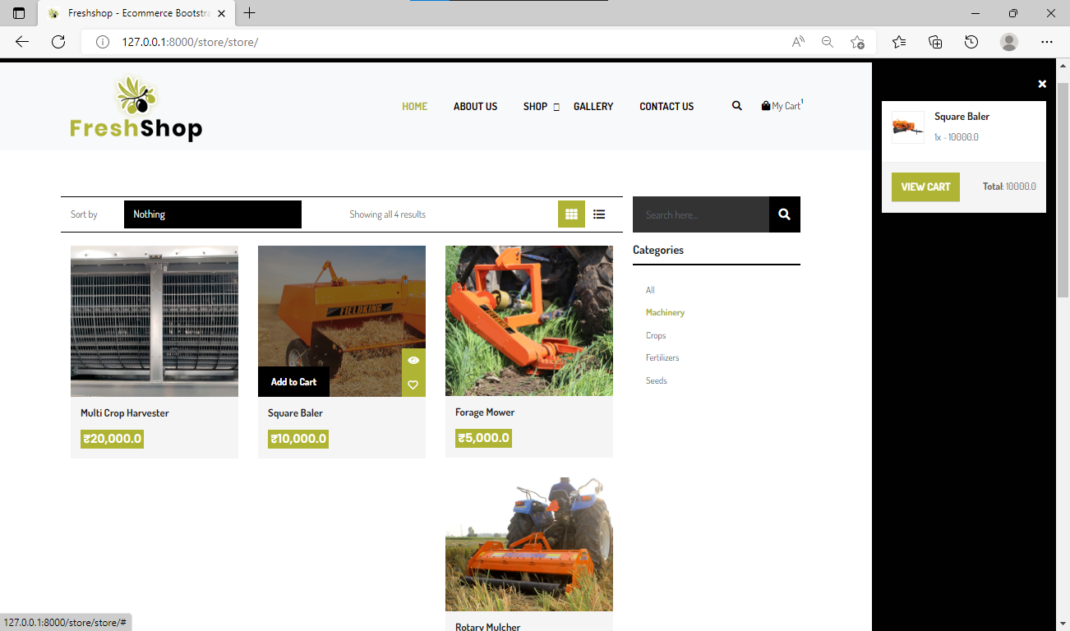

Figure 19: Add to Cart Functionality

**Description:** In the above figure, the middle cardboard section is our products. Once you hover, the add to cart button will appear. Clicking on that will update the user's cart, which is on the right side as shown in the fig.

* **Code highlights for the following:**

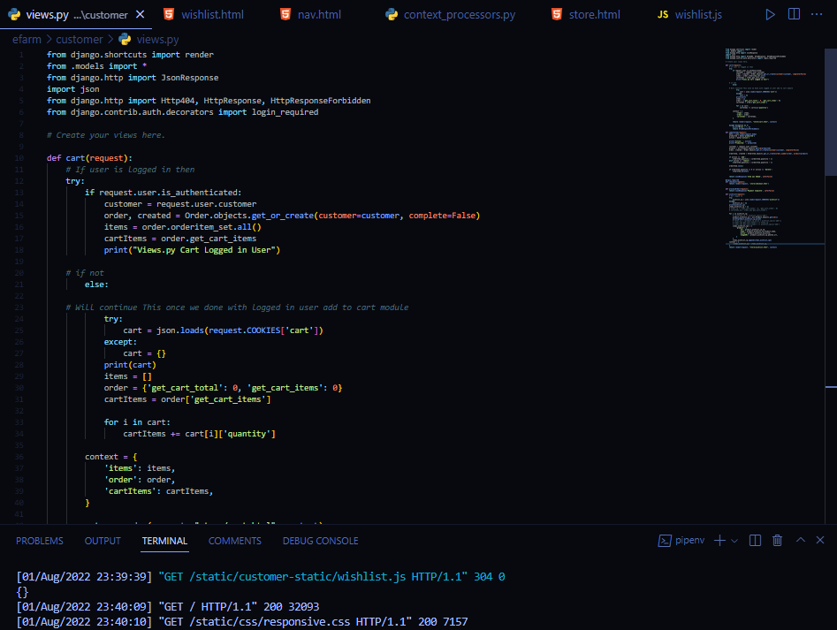

Figure 20: Product Page

1. **User’s Cart:**

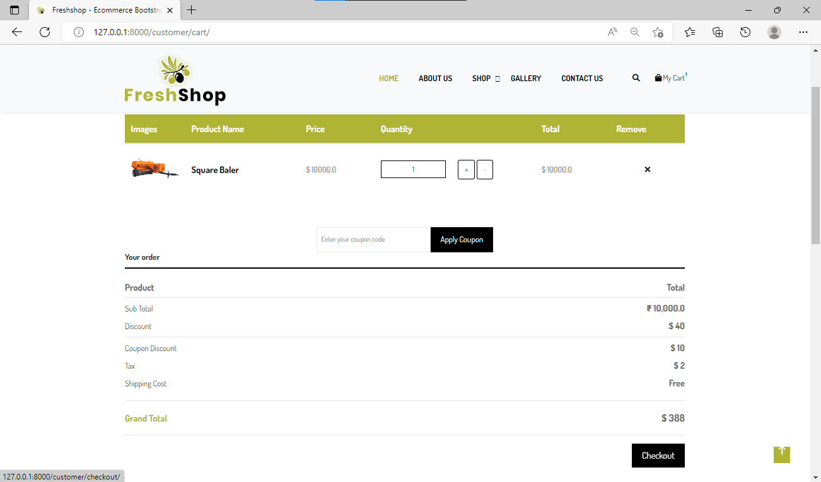

Figure 21: Cart Page

**Description:** Here, the user can see his/her cart and can easily update if needed. This page also shows the cart summary.

* **Code highlights for the following:**

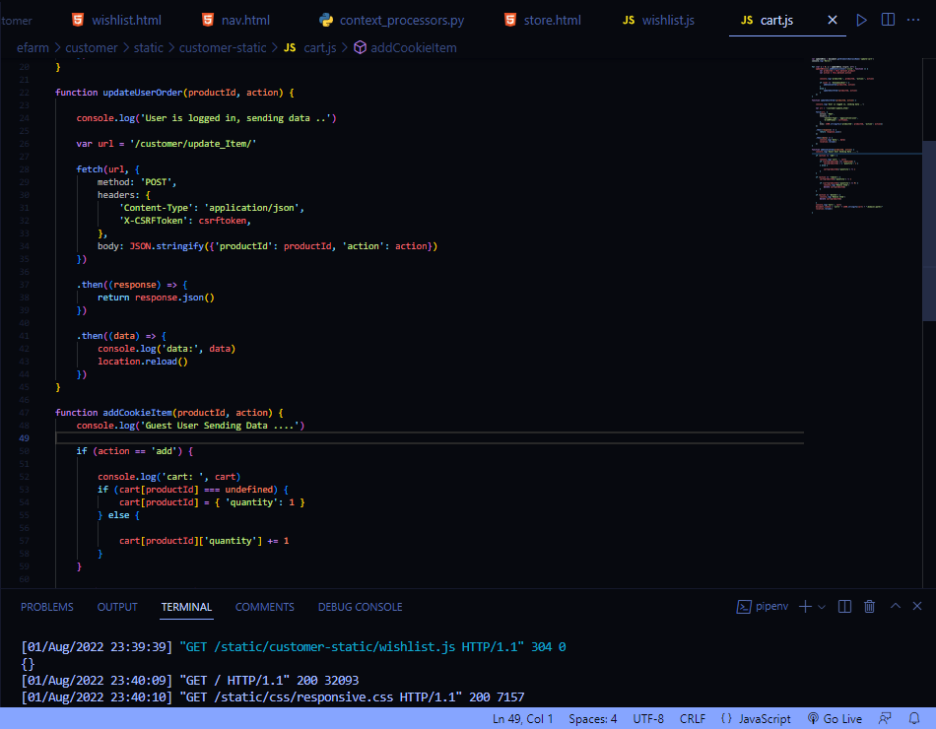

Figure 22: Cart page Code

1. **Checkout Page:**

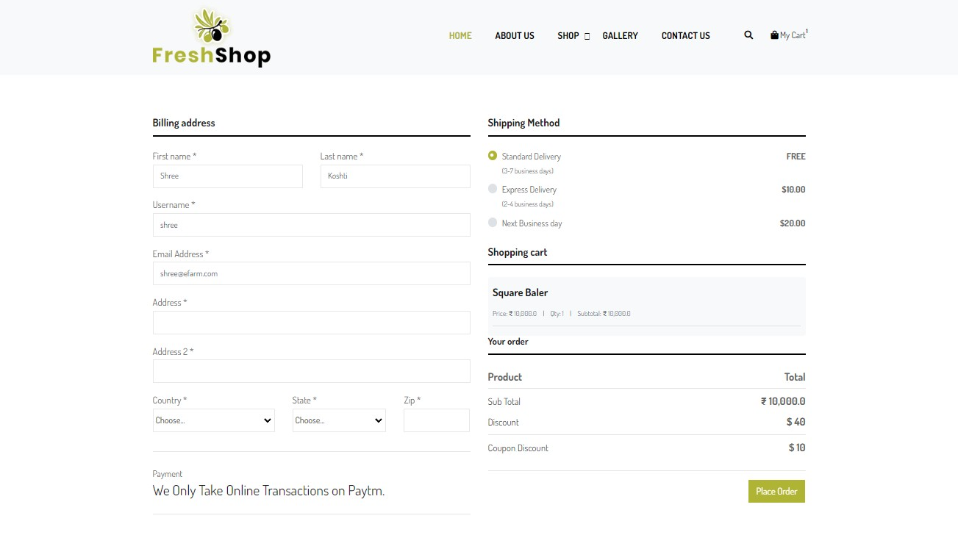

Figure 23 : Checkout Page

**Description:** This is the Checkout Page where users need to enter shipping details. To visit this page, a user needs to be logged in; otherwise, a user will be redirected to the login page. At the bottom right of the checkout page, there is a payment button to invoke the payment method.

* **Code highlights for the following:**

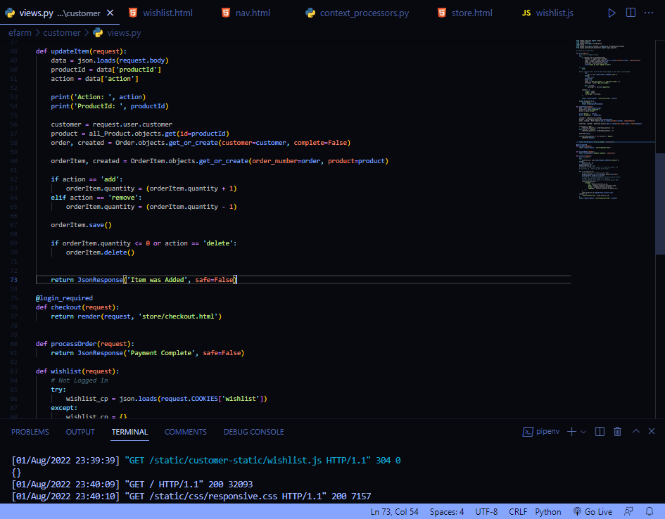

Figure 24 : Checkout Page Code

## Development Phase – 2

1. **Home Page:**

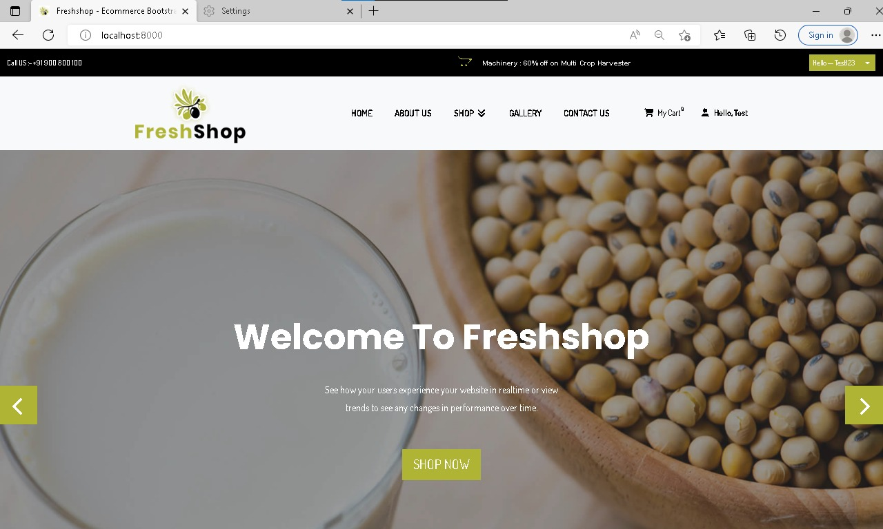

Figure 25 : Home Page - 1

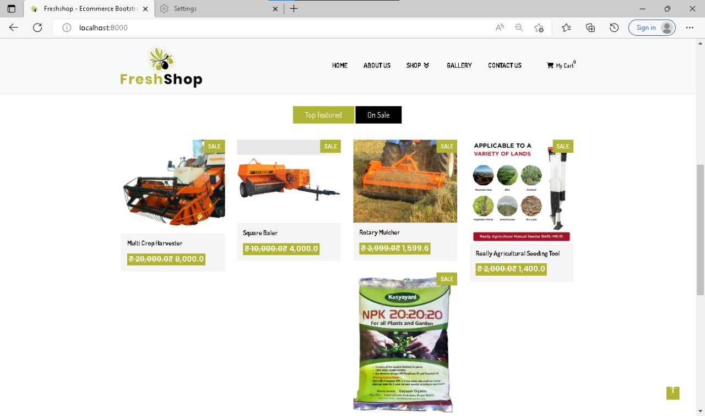

Figure 26 : Home Page – 2

**Description:** This is the Home Page where users comes when they open website.

* **Code highlights for the following:**

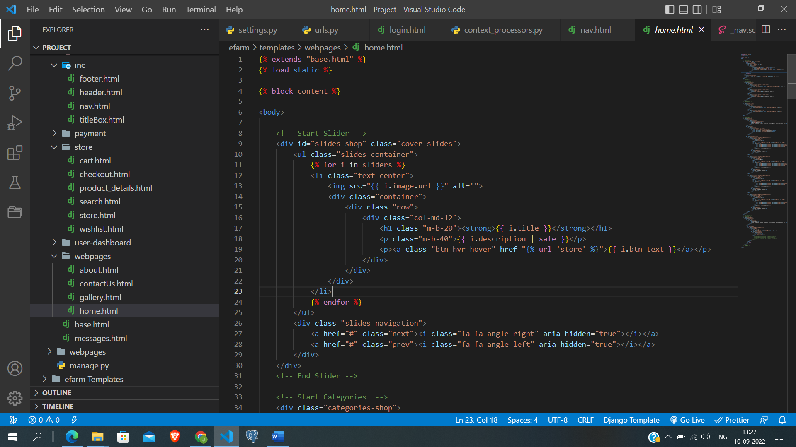

Figure 27 : Home Page Code

1. **My Accounts Page**

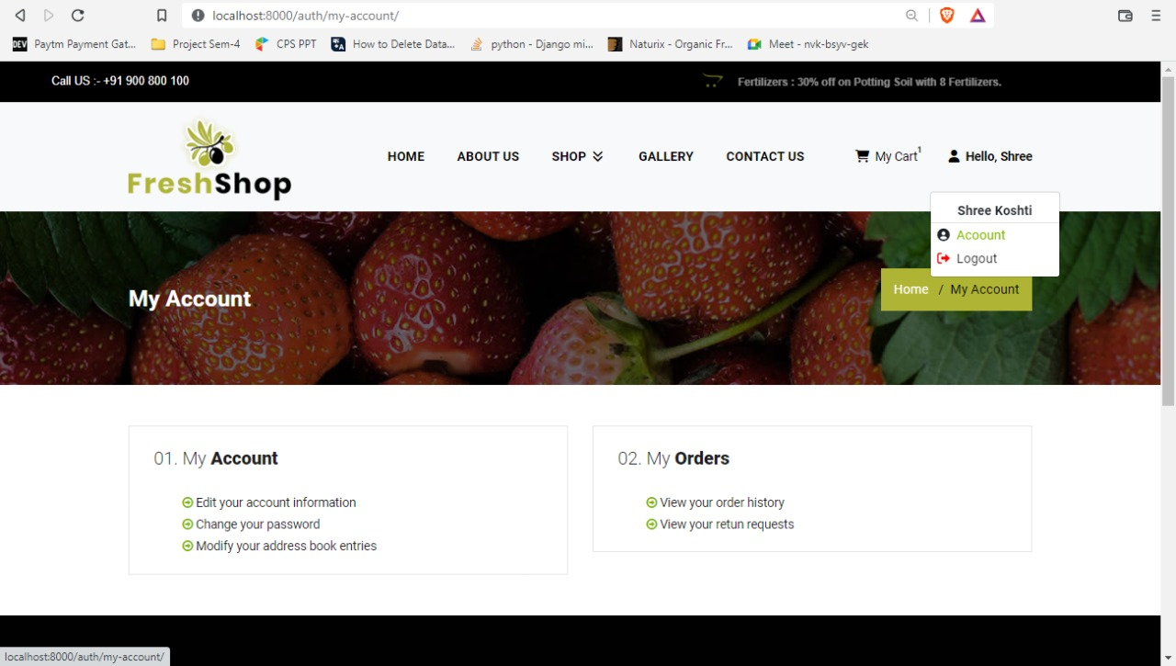

Figure 28 : My Account Design

**Description:** This is the Account Page where users can change their personal information , password as well as they can see orders option in that they can see all past orders list.

* **Code highlights for the following:**

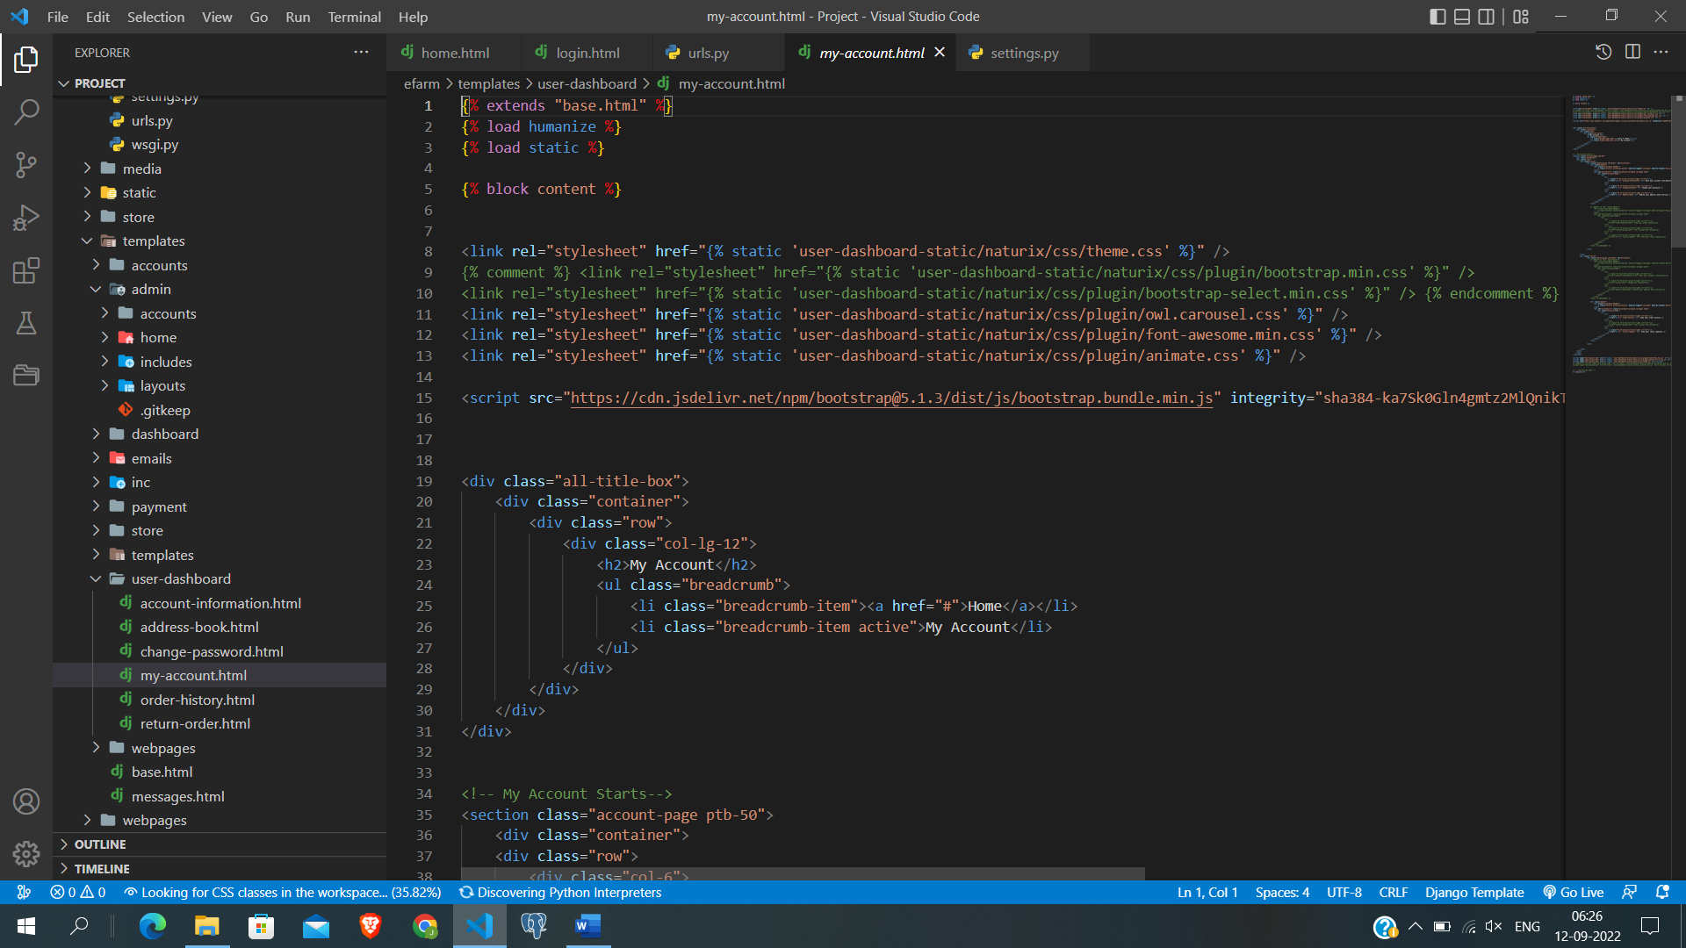

Figure 29 : My Account Code

## Development Phase – 3

## Admin SideBar

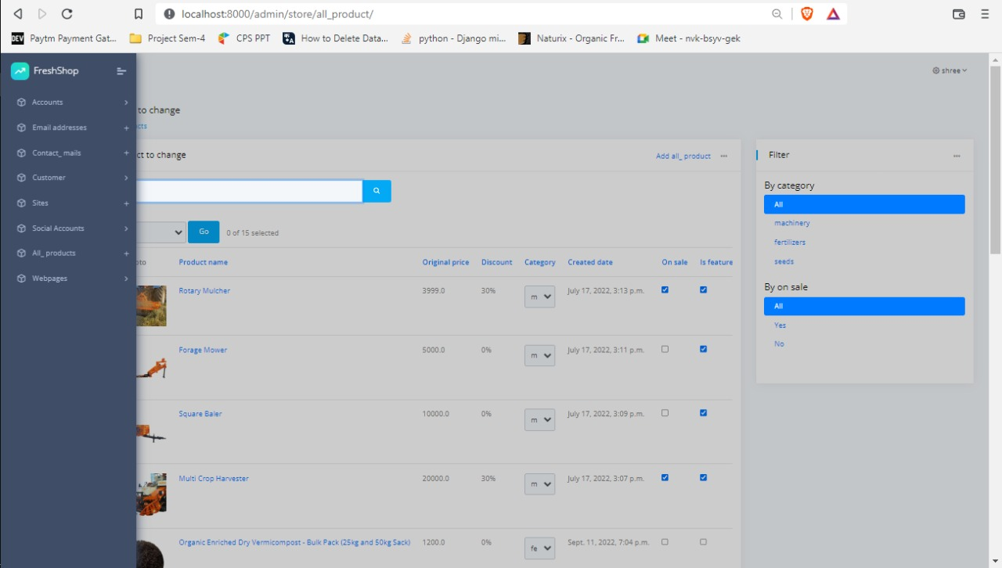

Figure 30 : Admin SideBar Design

**Description:** This is Admin Side navigation bar, this used redirect or go to another option.

* **Code highlights for the following:**

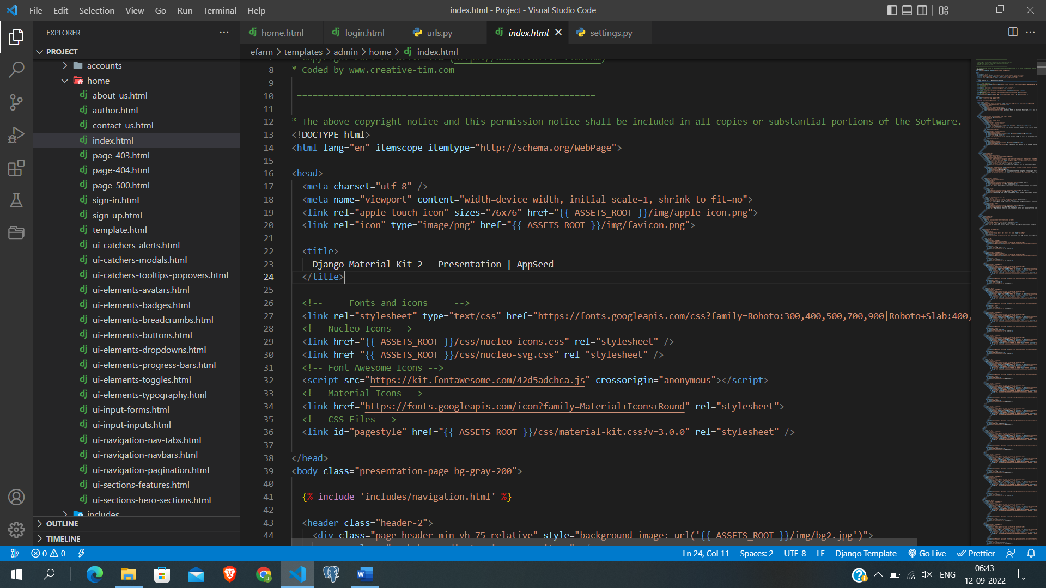

Figure 31 : Admin Sidebar Code

1. **Admin Products Page**

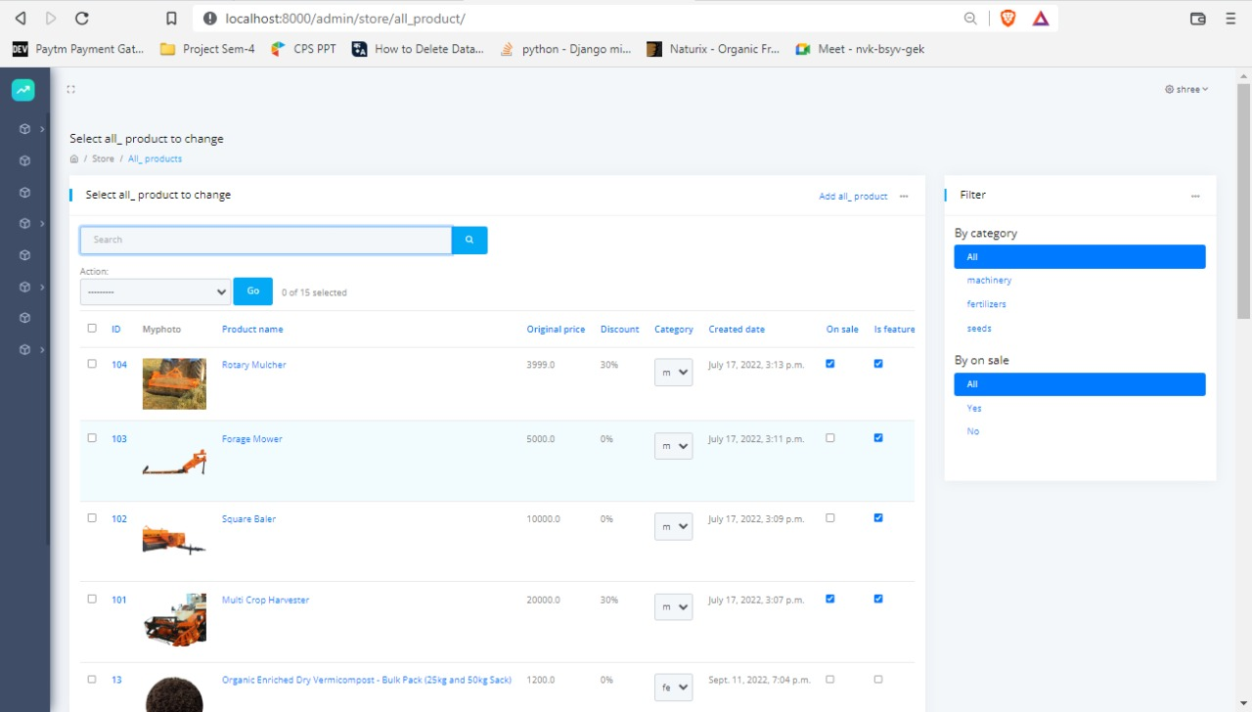

Figure 32 : Products Page – Admin

**Description:** This is Admin Manage product page where admin can manage all products. for instance: Add Products, Remove Products and Update Products.

* **Code highlights for the following:**

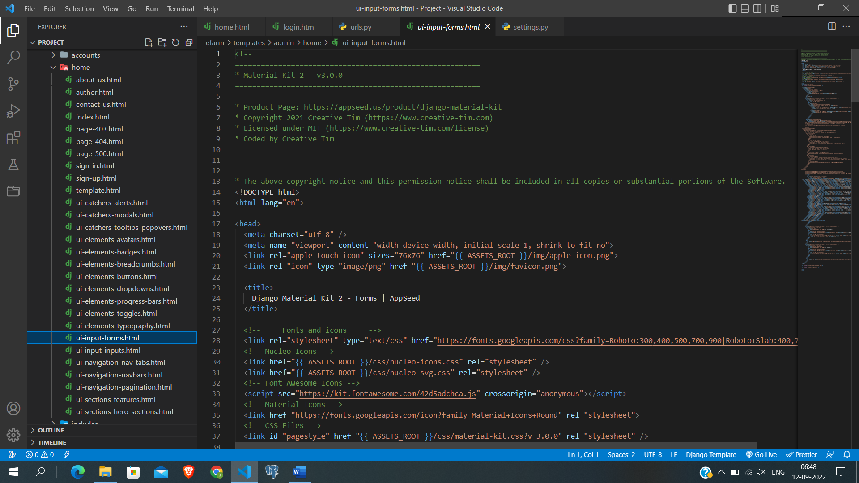

Figure 33 : Product Page Code - Admin

## Development Phase – 4

1. **Paytm Payment Page**

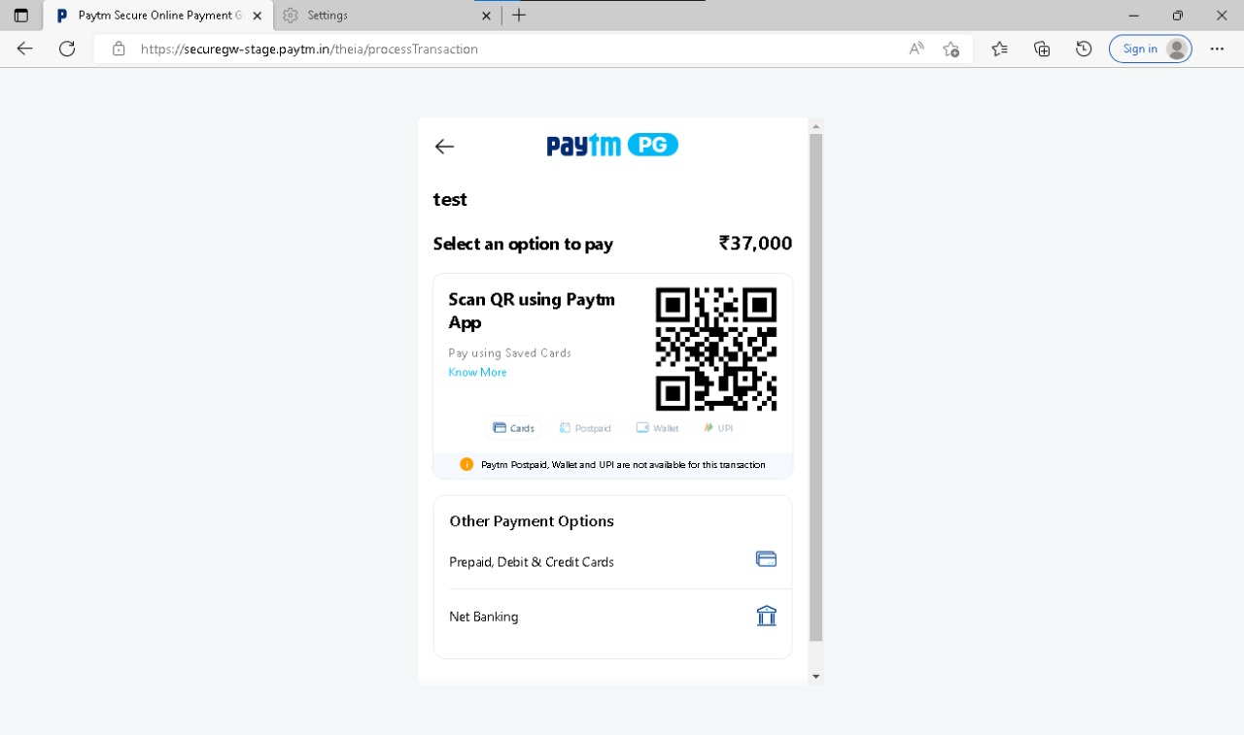

Figure 34 : Paytm Payment Design

**Description:** This is Paytm Paytm Page Where users can do online payment.

* **Code highlights for the following:**

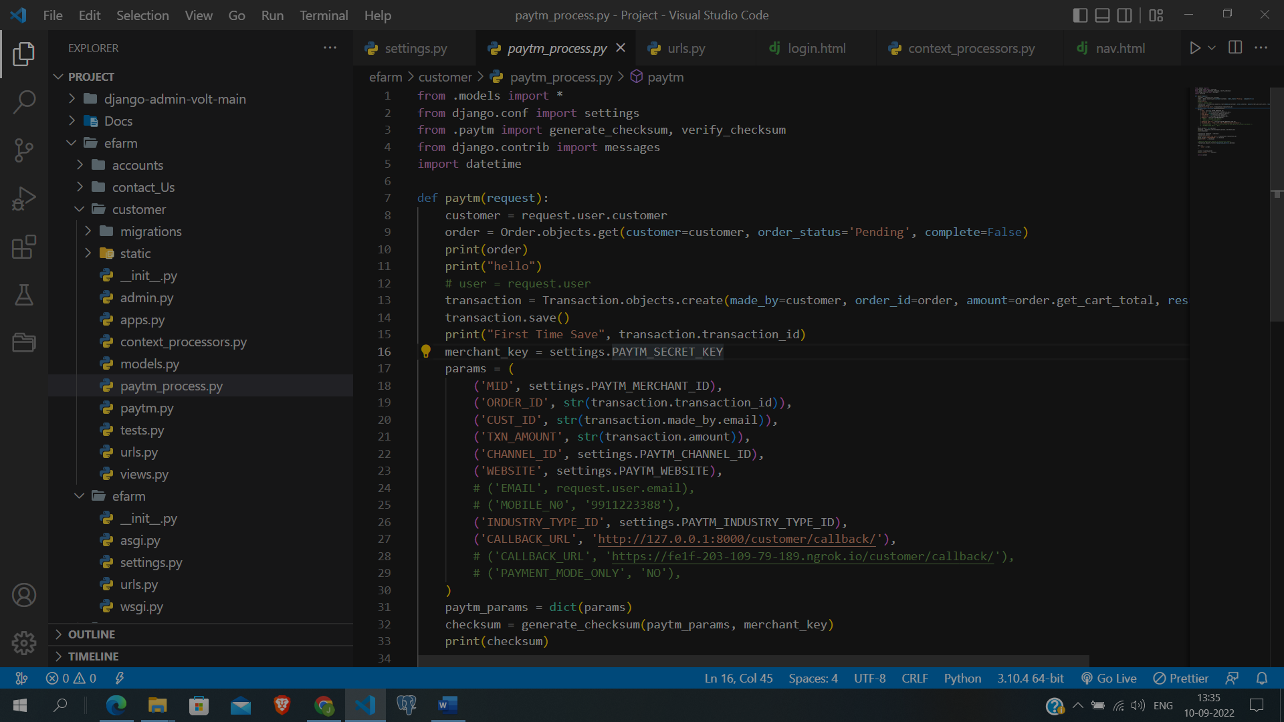

Figure 35 : Paytm Payment Code

1. **Order Confirm Email Template**

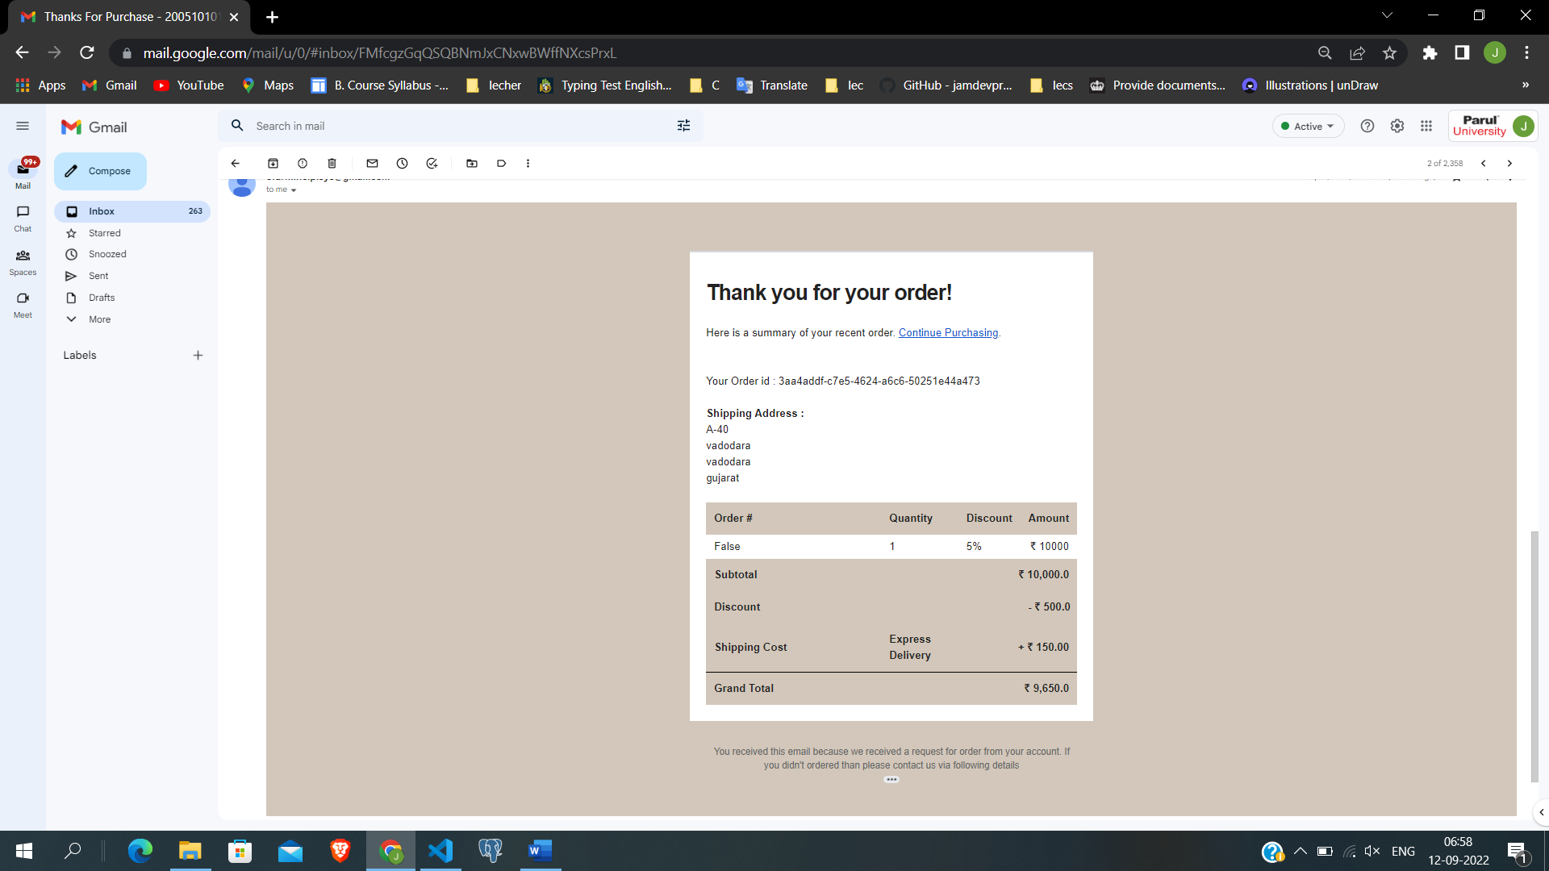

Figure 36 : Order Confirm Email Template Design

**Description:** This is Email Template used to send Confirmation order mail.

* **Code highlights for the following:**

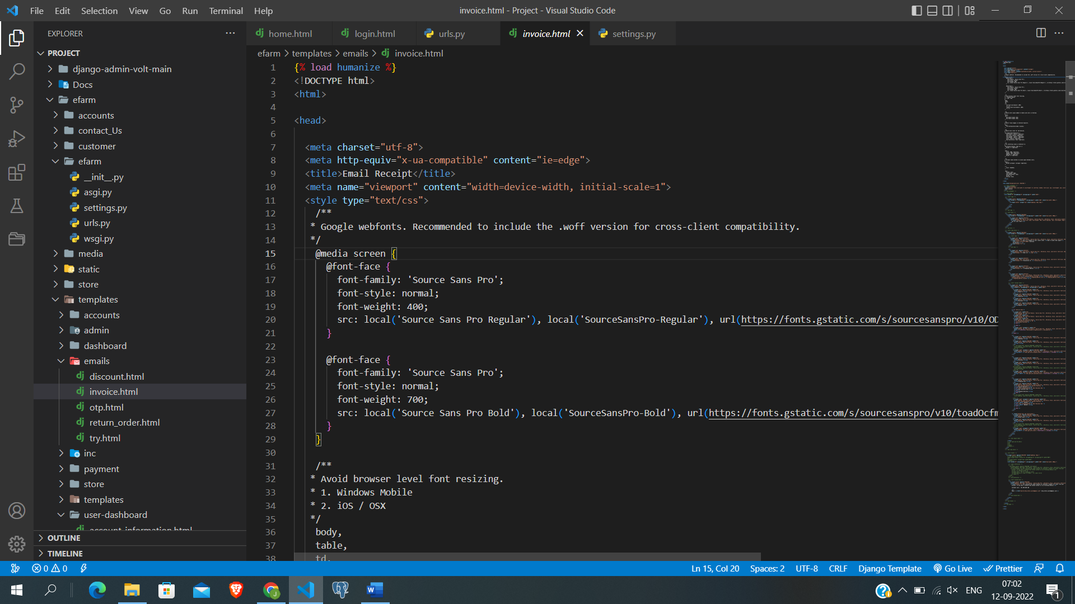

Figure 37 : Order Confirm Email Template Code

## Validation

## Change password validations

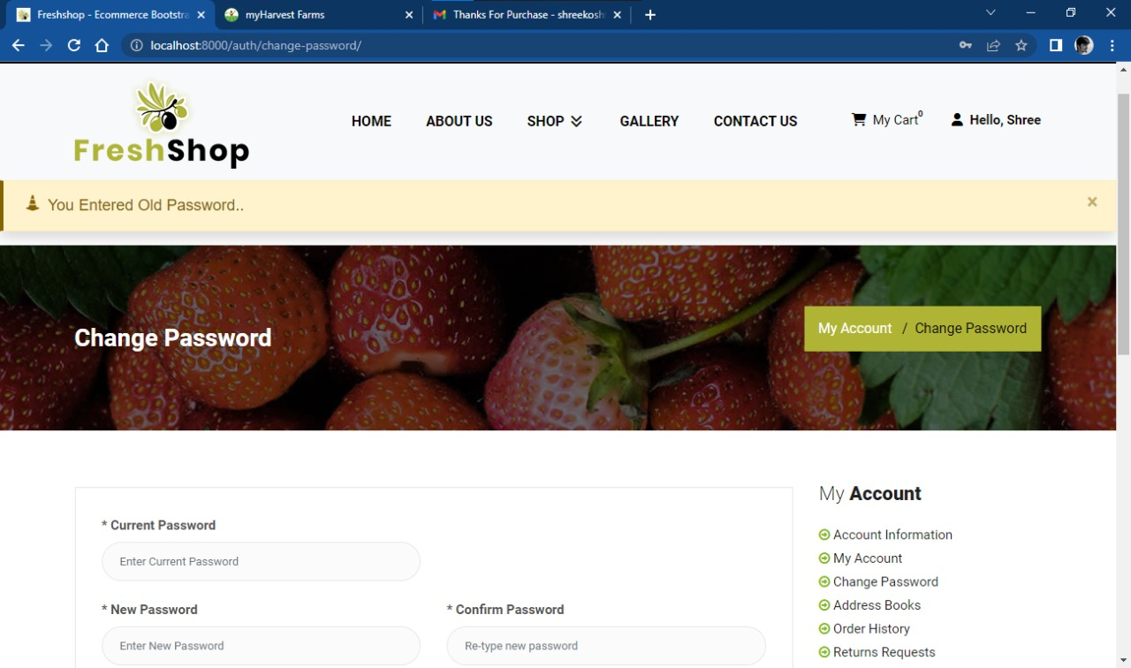

Figure 38 : Change password Validations Page

1. **Edit profile validation**

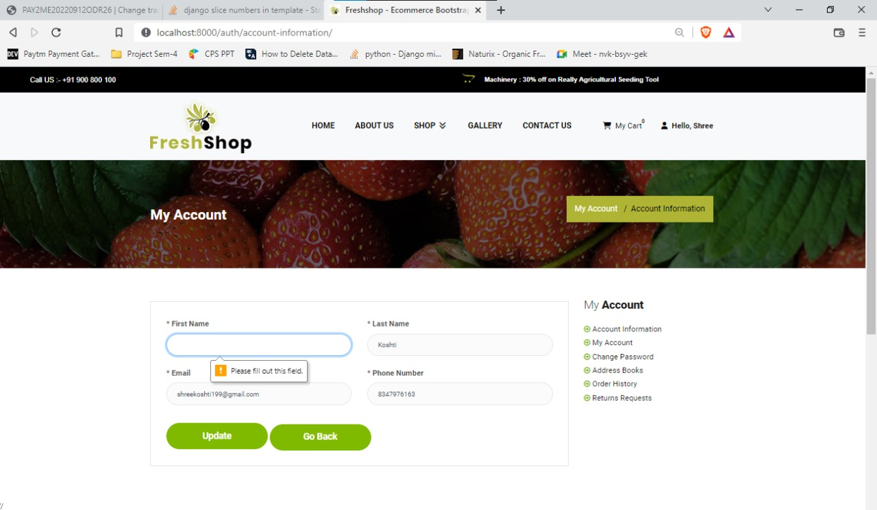

Figure 39 : Edit Profile page Validations

1. **Login Validations**

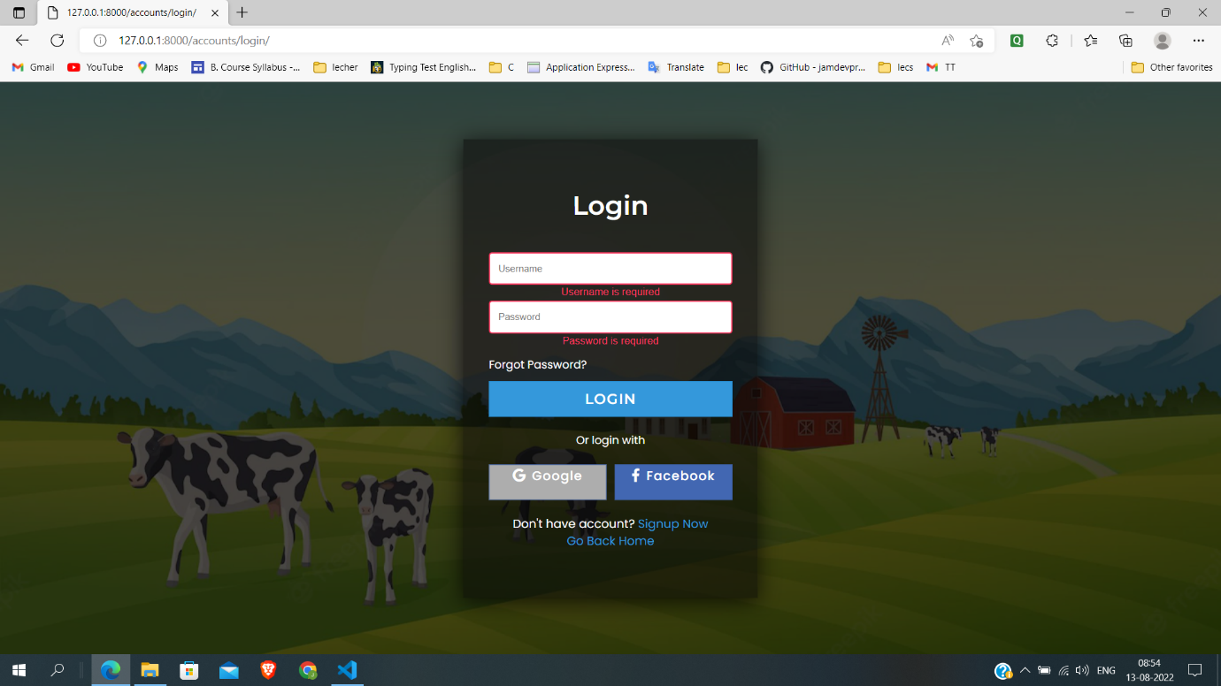

Figure 40 : Login Page Validations

# What is testing?

Software testing can be stated as the process of verifying and validating whether a software or application is bug-free, meets the technical requirements as guided by its design and development, and meets the user requirements effectively and efficiently by handling all the exceptional and boundary cases. The process of software testing aims not only at finding faults in the existing software but also at finding measures to improve the software in terms of efficiency, accuracy, and usability. It mainly aims at measuring the specification, functionality, and performance of a software program or application.

* 1. **Importance and types of testing**

To understand the importance of software testing, consider the example of Starbucks. In 2015, the company lost millions of dollars in sales when its point-of-sale (POS) platform shut down due to a faulty system refresh caused by a software glitch. This could have been avoided if the POS software had been tested thoroughly. Nissan also suffered a similar fate in 2016 when it recalled more than 3 million cars due to a software issue in airbag sensor detectors.

The following are important reasons why software testing techniques should be incorporated into application development:

* Identifies defects early
* Improves product quality
* Increases customer trust and satisfaction
* Detects security vulnerabilities
* Helps with scalability
* Saves money
  1. **Types of testing**
* **Unit Testing**

It focuses on the smallest unit of software design. In this, we test an individual unit or group of interrelated units. It is often done by the programmer by using sample input and observing its corresponding outputs.

Example:

* In a program we are checking if the loop, method, or function is working fine
* Misunderstood or incorrect, arithmetic precedence.
* Incorrect initialization
* **Integration Testing**

The objective is to take unit-tested components and build a program structure that has been dictated by design. Integration testing is testing in which a group of components is combined to produce output.

Integration testing is of four types:

* Top-down
* Bottom-up
* Sandwich
* Big-Bang

Example:

(a) Black Box testing: - It is used for validation. In this, we ignore internal working mechanisms and focus on what is the output?

(b) White box testing: - It is used for verification. In this, we focus on internal mechanisms i.e. how the output is achieved?

* **Regression Testing**

Every time a new module is added leads to changes in the program. This type of testing makes sure that the whole component works properly even after adding components to the complete program.

Example: In school, record suppose we have module staff, students and finance combining these modules and checking if on integration of these modules works fine in regression testing.

* **Smoke Testing**

This test is done to make sure that the software under testing is ready or stable for further testing It is called a smoke test as the testing of an initial pass is done to check if it did not catch the fire or smoke in the initial switch on.

Example: If the project has 2 modules so before going to the module make sure that module 1 works properly.

# Future Enhancement

* Delivery status will be more efficient at user side.
* More payment modes will be add Ex, UPI ,COD.
* Delivery status will be updated by delivery boy at mobile location.
* Make more user-friendly UI.
* More enhanced admin side.ssss
* In future we will create android as well as IOS mobile application.

# References & Bibliography

* **Website**:
  1. <https://docs.djangoproject.com/en/3.2/>
  2. <https://www.python.org/doc/>
  3. <https://stackoverflow.com/>
* **Book** :

1. Django for Beginners: Build websites with Python and Django

(William S Vincent)

1. Think Python : How to Think Like a Computer Scientist

(Allen Downey)

1. The Elements of Uml (tm) 2.0 Style

(Scott W. Ambler)